ÖZEL

B52-Team 2 PBL CMPS 312 FALL 2022

Raghad Aqel (201901919)

Manel Riahi (201805149)

Meriem Bousaa (201902903)

Islam Hamdi (202004552)

Anjoud Al-Romaihi (201800583)

Contents

Motivation 2

Initial GUI Design 3

Final Implemented Design 7

Database Design 16

Design and Architectural Patterns 18

Implementation 20

Additional Features 28

New Gained Knowledge and Skills 29

Reflections 34

Resources 36

Appendix A: Json Files

# Motivation

It is almost impossible for any person to deny how much the COVID-19 pandemic has shaped our lifestyles. This pandemic has enormously affected many industries and the retail industry was no exception. Especially after the wide closure of several stores and businesses worldwide. E-commerce has proven to be exceptionally well placed to facilitate the digitalization of the retail field by delivering goods directly from warehouses to consumers. Since the outbreak, shops in Qatar have had their share of shutdowns and closures as well as a shortage of customers due to the country's health regulations. Therefore, numerous stores have tried out different methods of reaching out to their clients.

Our application, Özel, is an easy-to-use software that runs on the Android operating system. It seeks to develop an online solution, specifically an e-commerce store, that will help business owners. It allows them to present their products to their customers and enable them to purchase things from the app using any android operating system device from the comfort of their home. Customers will be able to browse products, place orders, add reviews and more in an effectively contactless way. This is a flawless shopping experience for both merchants and buyers. As customers will no longer need to visit stores to buy goods since they will be able to do so from any place using our App. As for business owners, it will help them to present items without the constraints of a physical store.

All in all, the primary goal of this project is to design, develop, and deploy an Android-based online retail application that will help local merchants, small business owners, and start-ups get started and connect with their customers.

# Initial GUI Design

Adobe XD was used to craft the initial design of our application. It is an Adobe prototyping tool for user experience. Its features include creating wireframes, prototypes, and screen designs for digital products such as mobile apps. Another software used was Adobe Illustrator. Adobe Illustrator is a graphic design application. It was used to create the logo of our application and some of the images used.

After doing some research we concluded that most applications nowadays have a minimal style and they use from 2-3 colors for the whole application. For example, ASOS and Farafetch. Therefore, for our application the color scheme we chose was a special shade of blue (0xff0076a3), white and grey. For all the screens only these three colors were used. We tried our best to not make the application complicated. Thus, as seen in the figures below all the screens were designed in the same way to make the application as user friendly and aesthetically pleasing as possible.

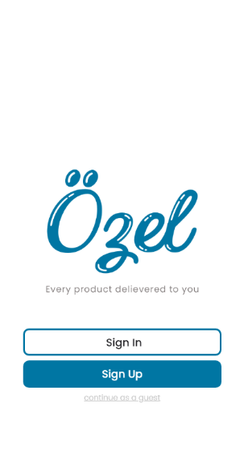

Figure 1. WelcomePage

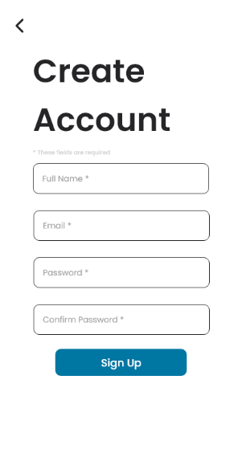

Figure 2. Use Case 1 - Register

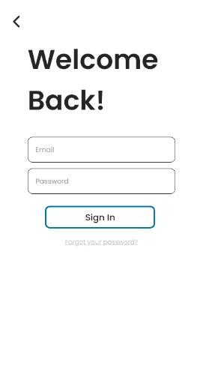

Figure 3. Use Case 2 – Login

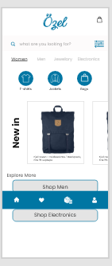

Figure 4. Use Case 3 Products Screen 1

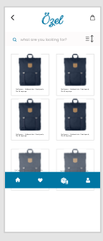

Figure 5. Use Case 3 Products Screen 2

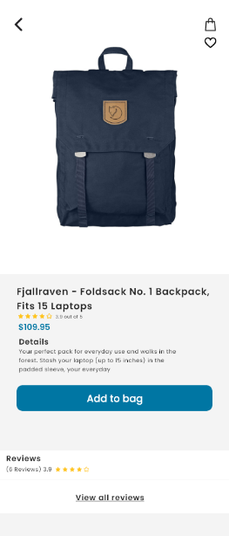

Figure 6. View product

As seen in the figure below it was also taken into consideration what image will appear if the cart is empty.

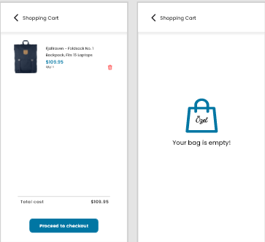

Figure 7. Use Case 4 – Cart

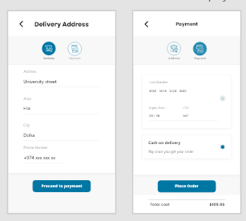

Figure 8. Use Case 5 – Orders V1

As shown in figure 6 for the order details and my orders screen it was inspired by a flutter developer Andrey Poteryahin via a website called medium [5]. It’s a website where people share their UI designs.

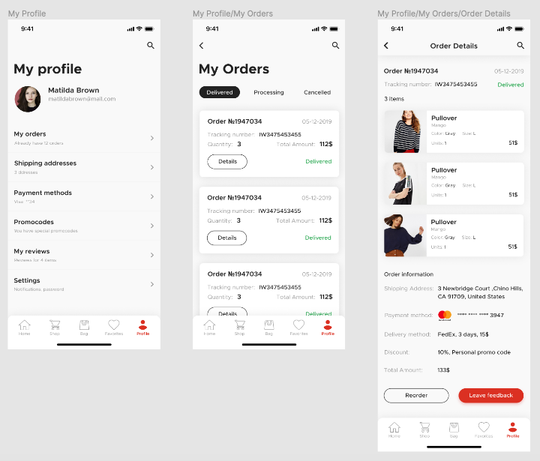

Figure 9. Use Case 5 - Orders V2

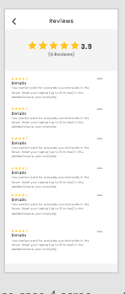

Figure 10. Use Case 6 – Reviews

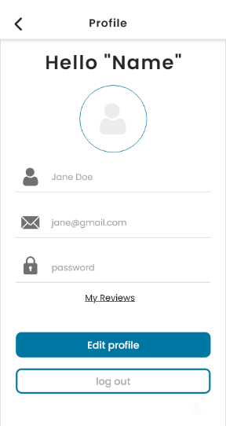

Figure 11. Profile

# Final Implemented Design

For the final implemented design minor changes happened when compared to the initial design. For example, “my orders” in the initial design was included in the bottom bar but the implemented bottom bar only has three screens: home, wish list and profile. As putting too many tabs in a bottom bar may make it difficult for people to tap the one they want. Moreover, for the profile after doing some research and downloading retail applications we realized that the design for the profile was not suitable as the layout was not user friendly and outdated.

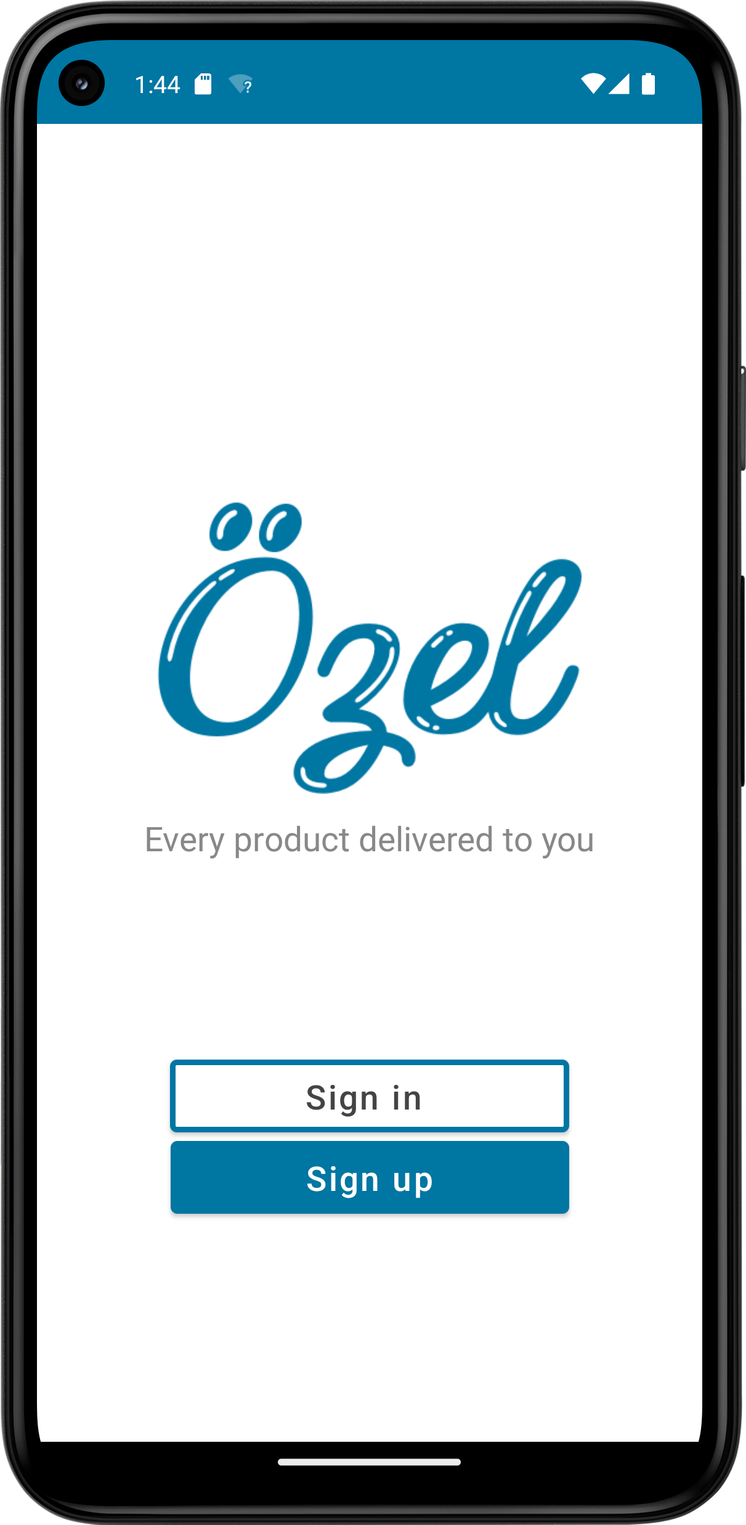

Figure 12. Welcome Page Screen

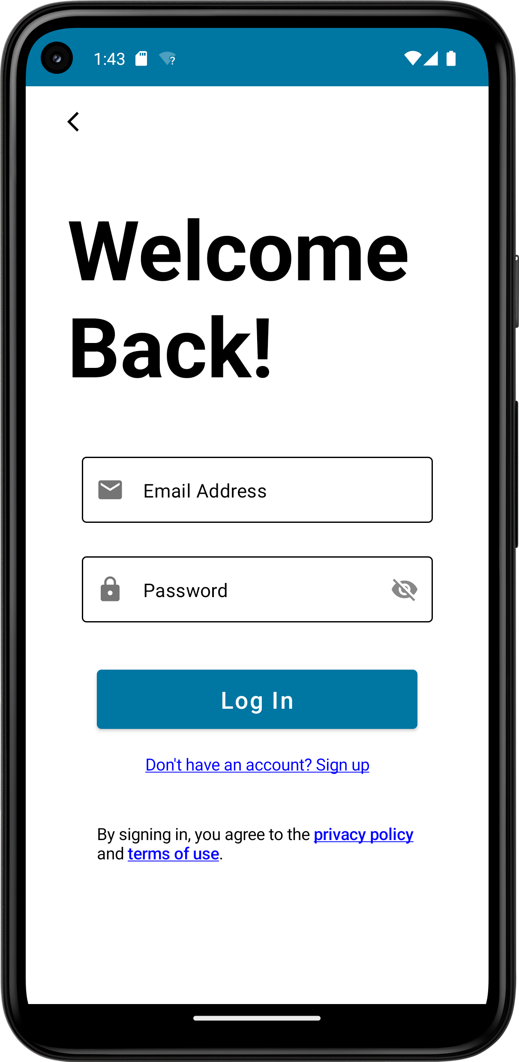

Figure 13.Login Screen

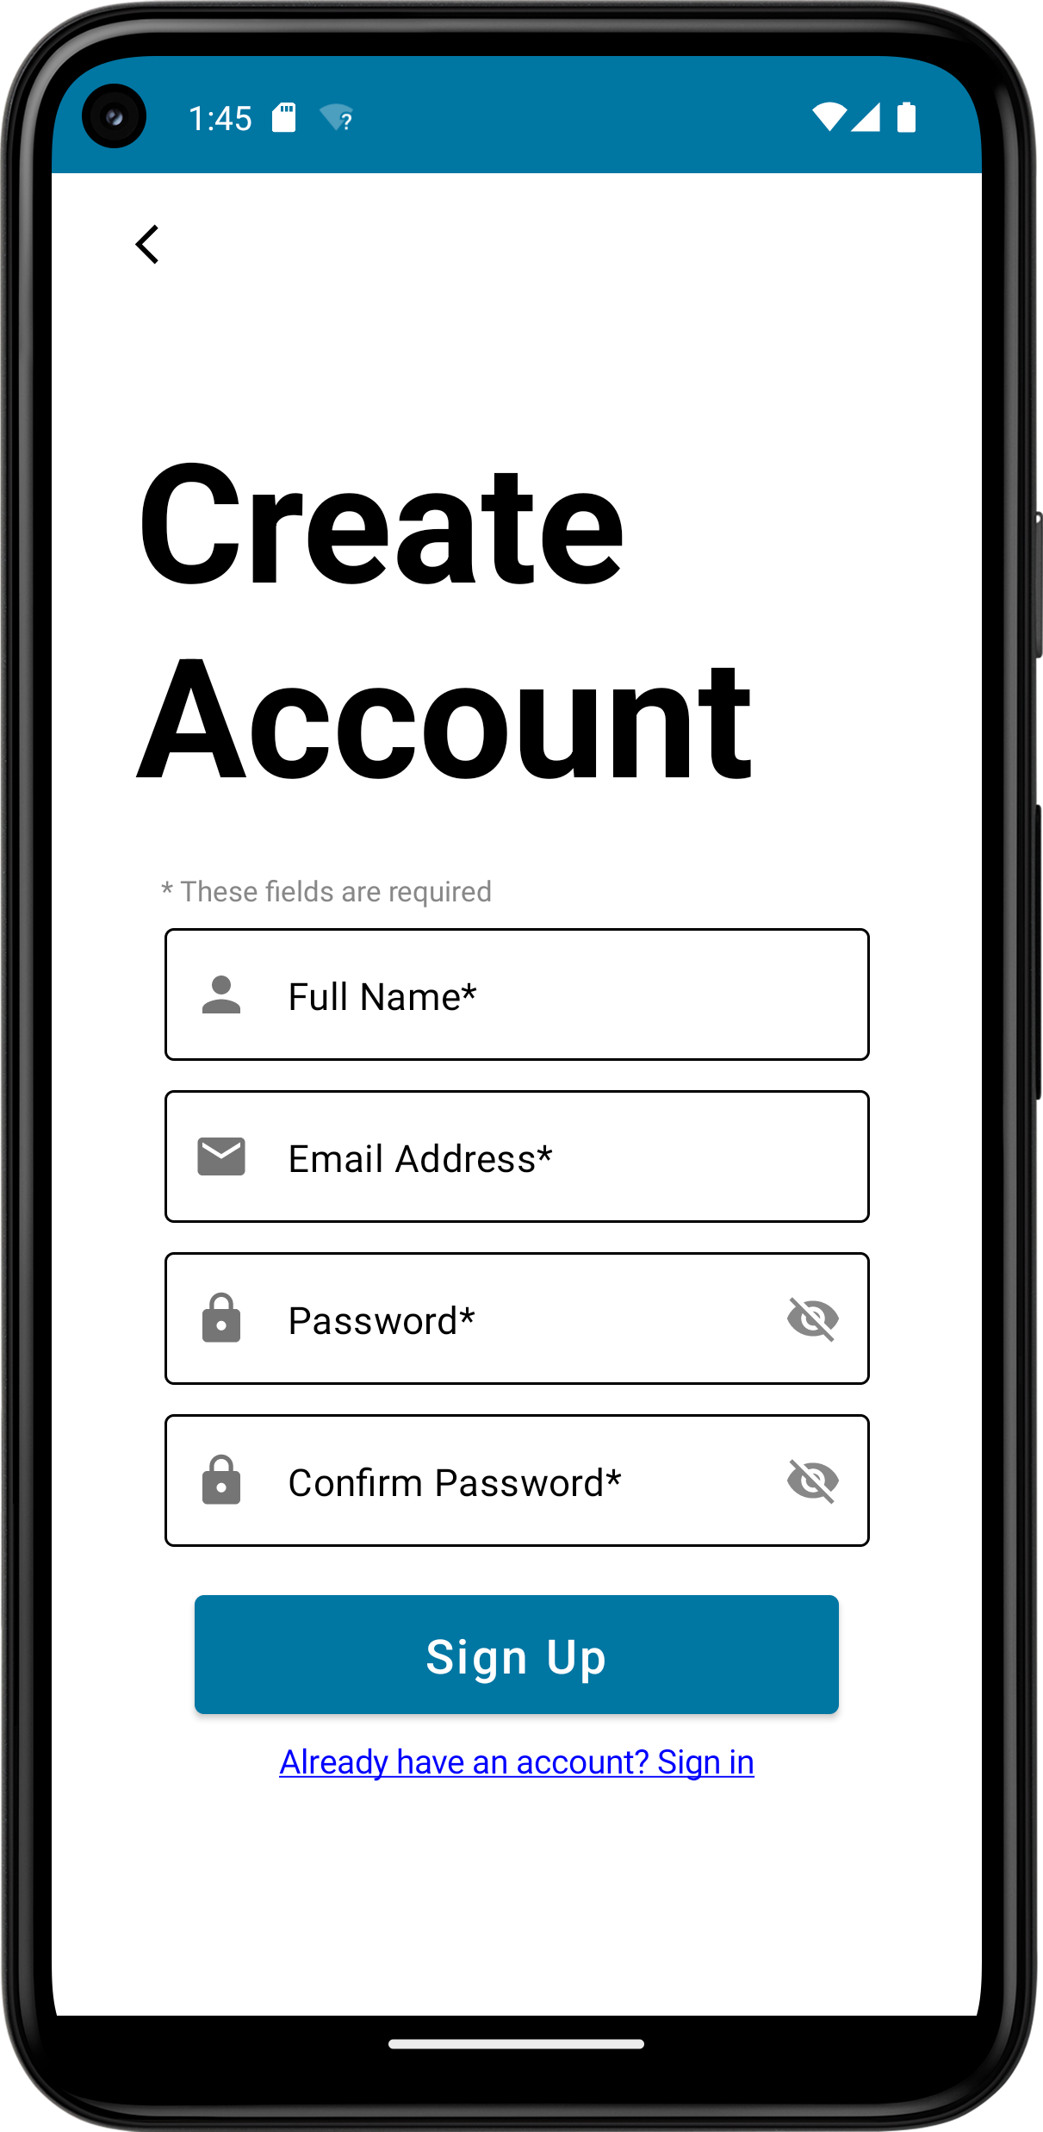

Figure 14. Register Screen

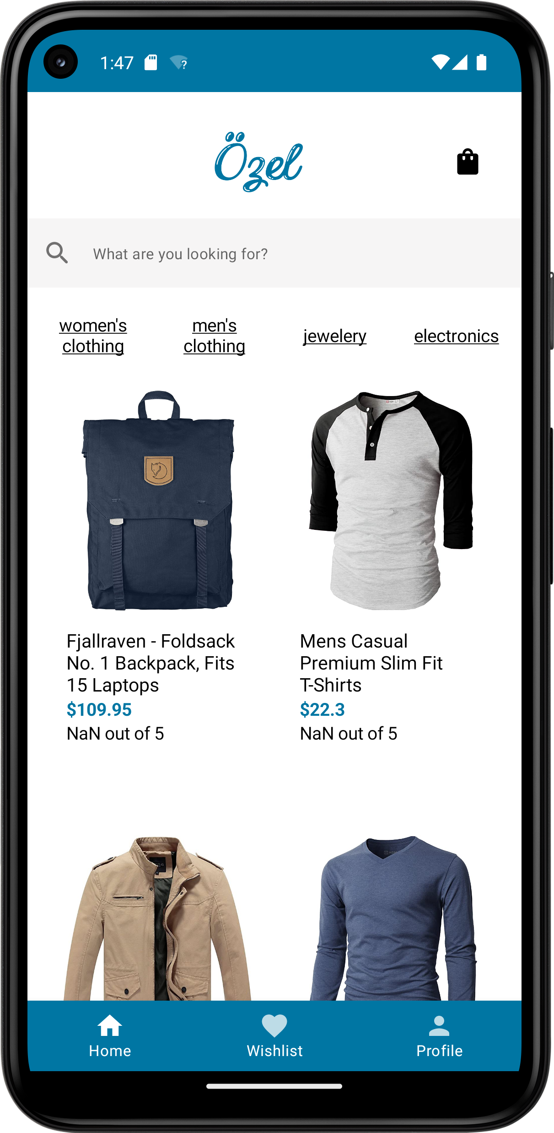

Figure 15. Home Screen

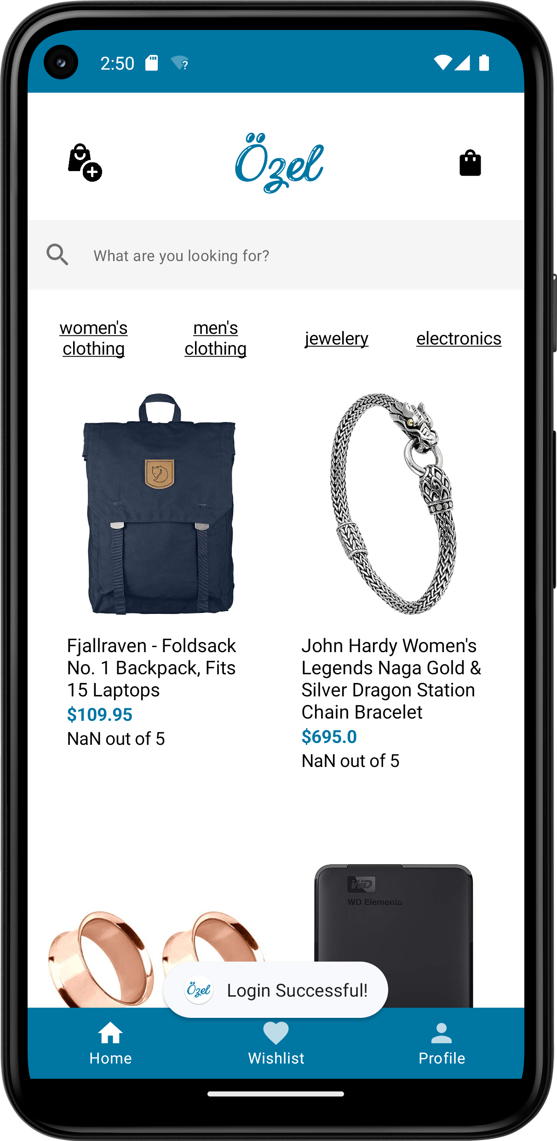

Figure 16. Admin Home Screen

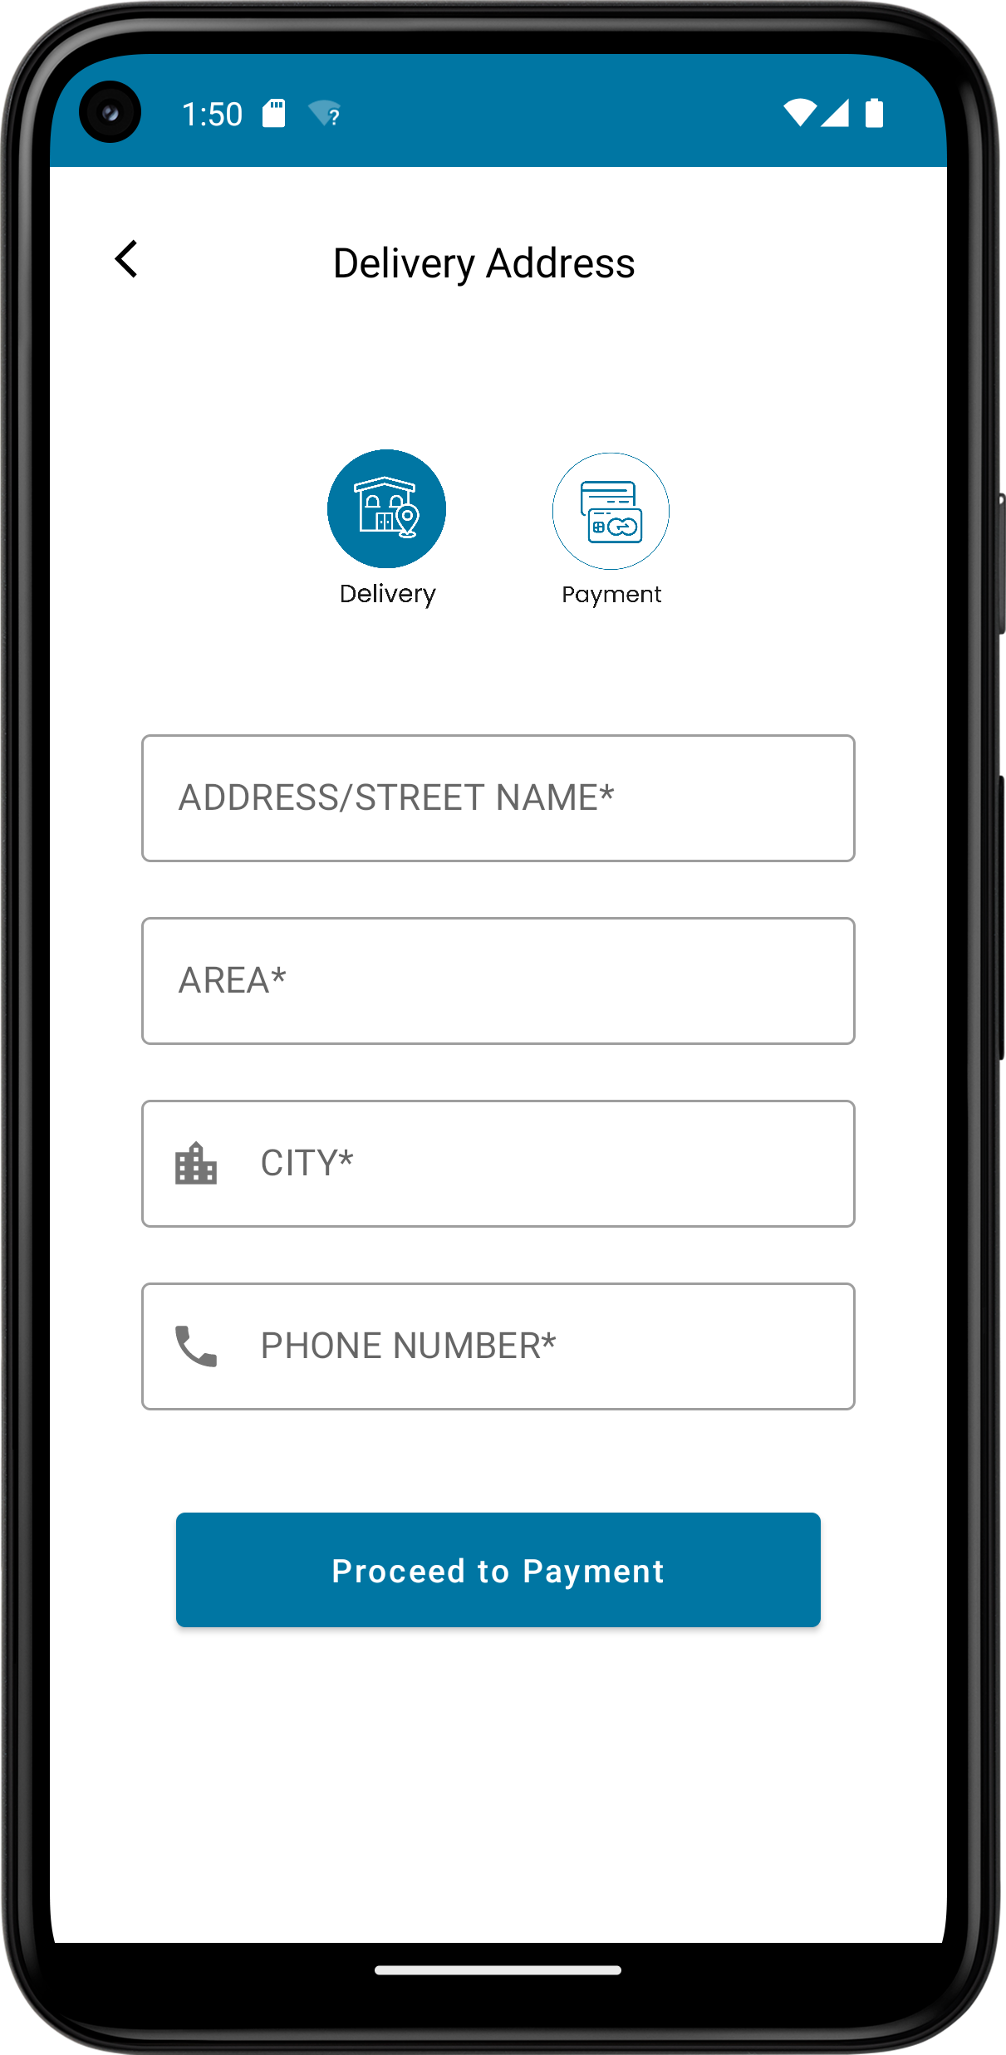

Figure 17. Add delivery Screen

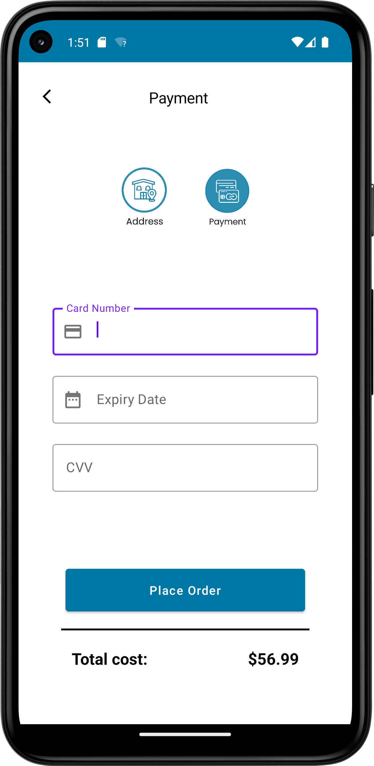

Figure 18. Payment Screen

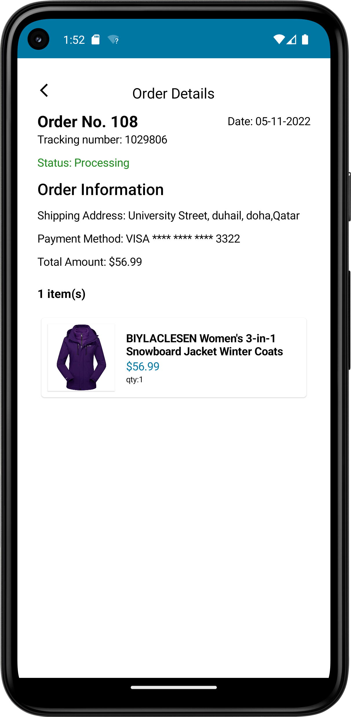

Figure 19. Order Details Screen

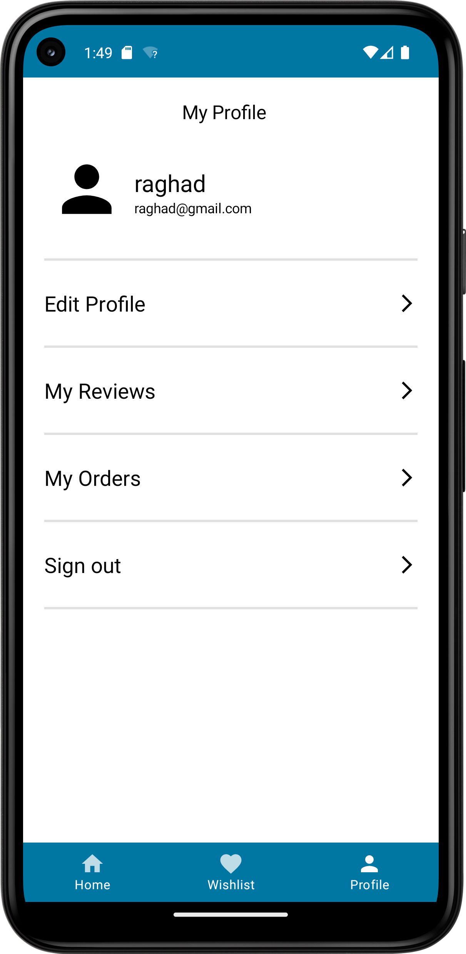

Figure 20. Profile Screen

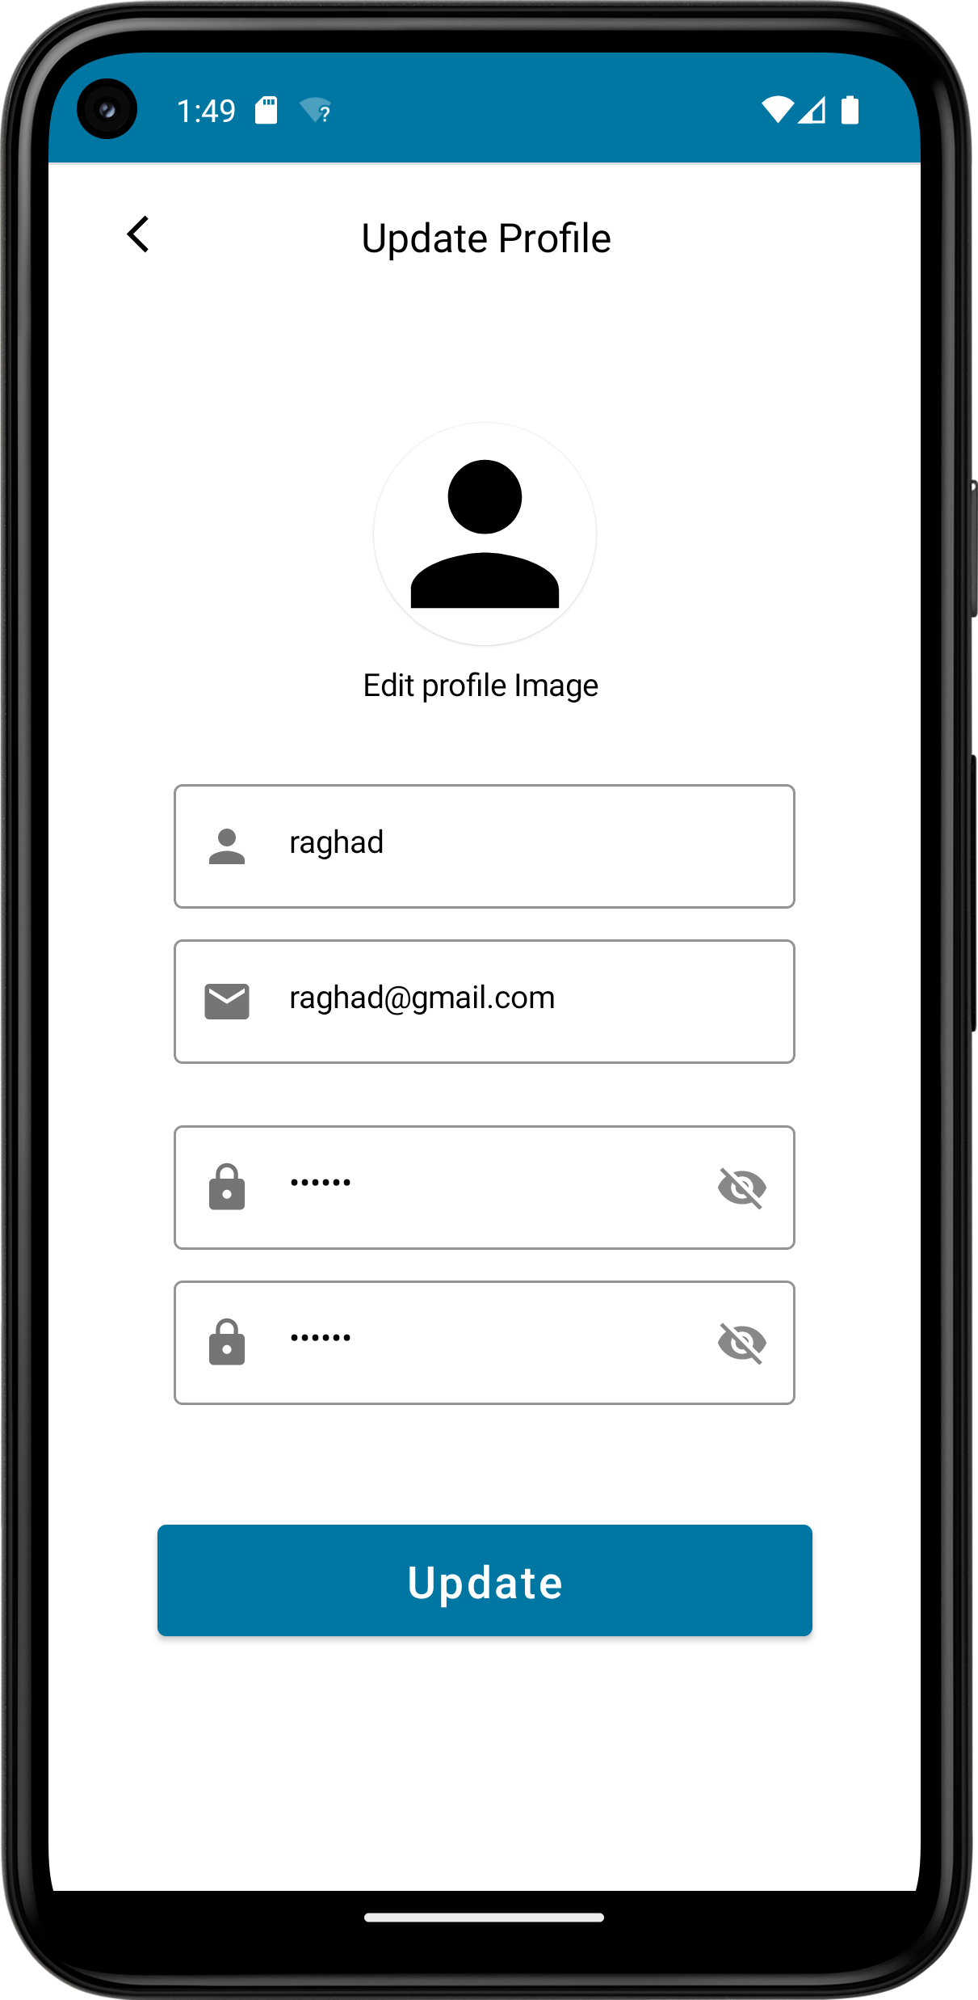

Figure 21. Edit Profile Screen

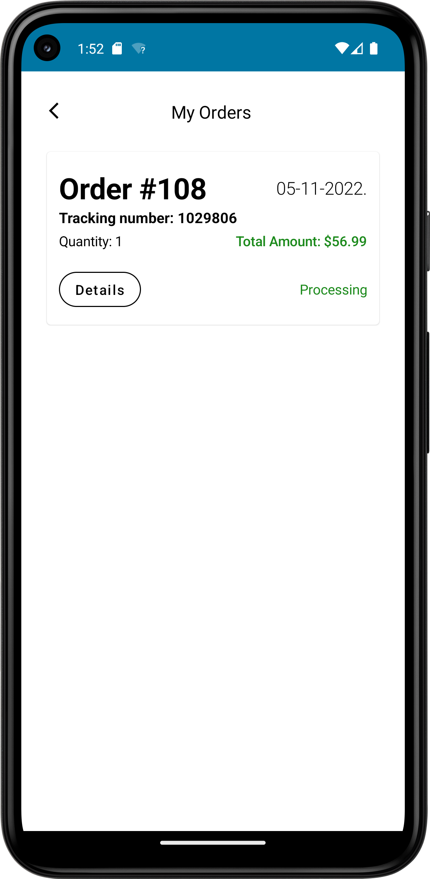

Figure 22. My orders Screen

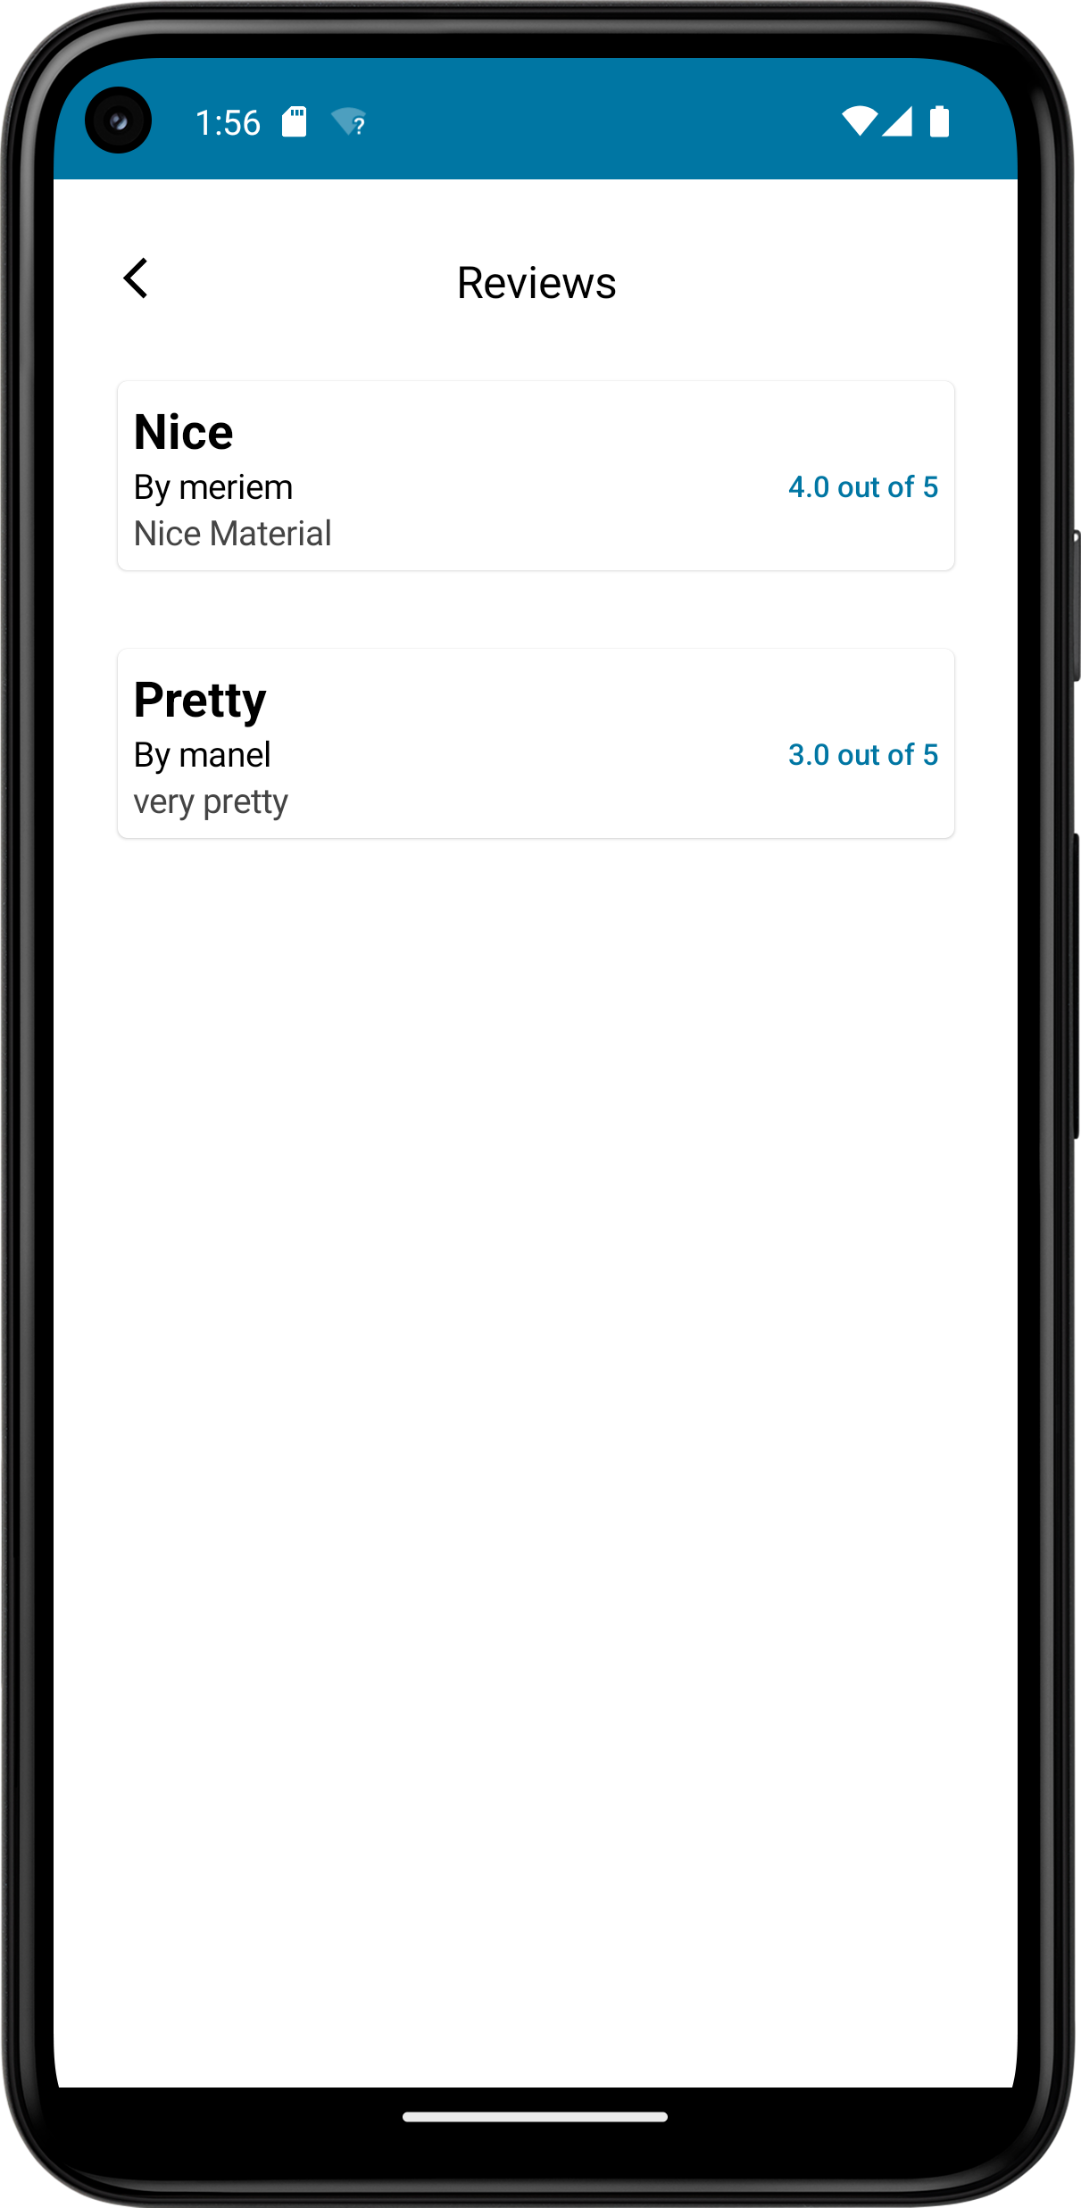

Figure 23. Product Reviews Screen

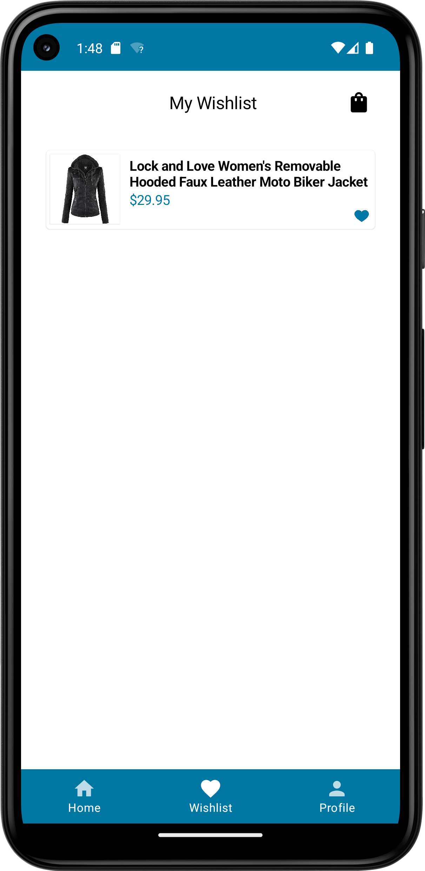

Figure 24. Wishlist Screen

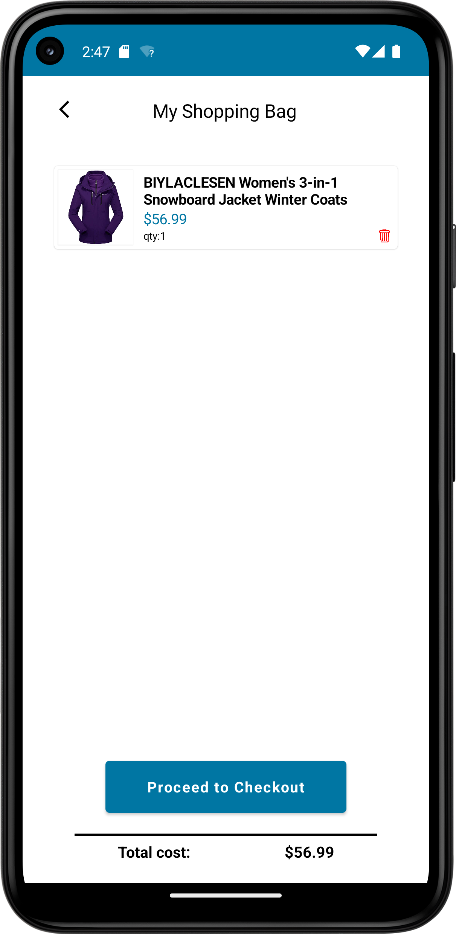

Figure 25. Shopping Bag Screen

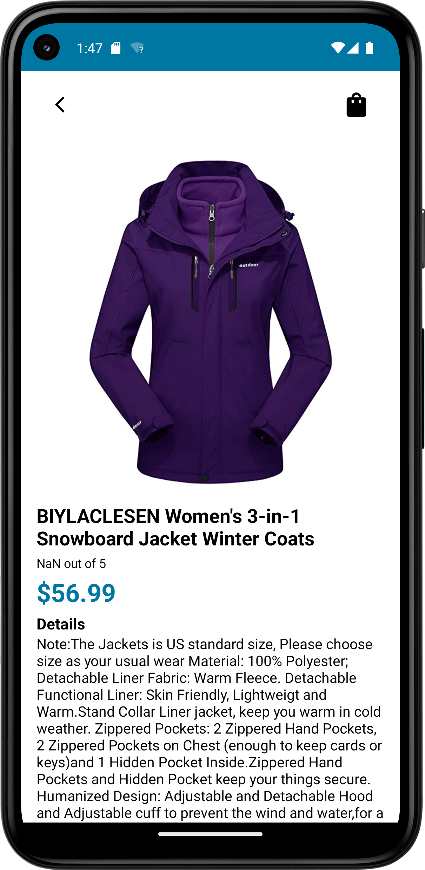

Figure 26. Product Details Screen

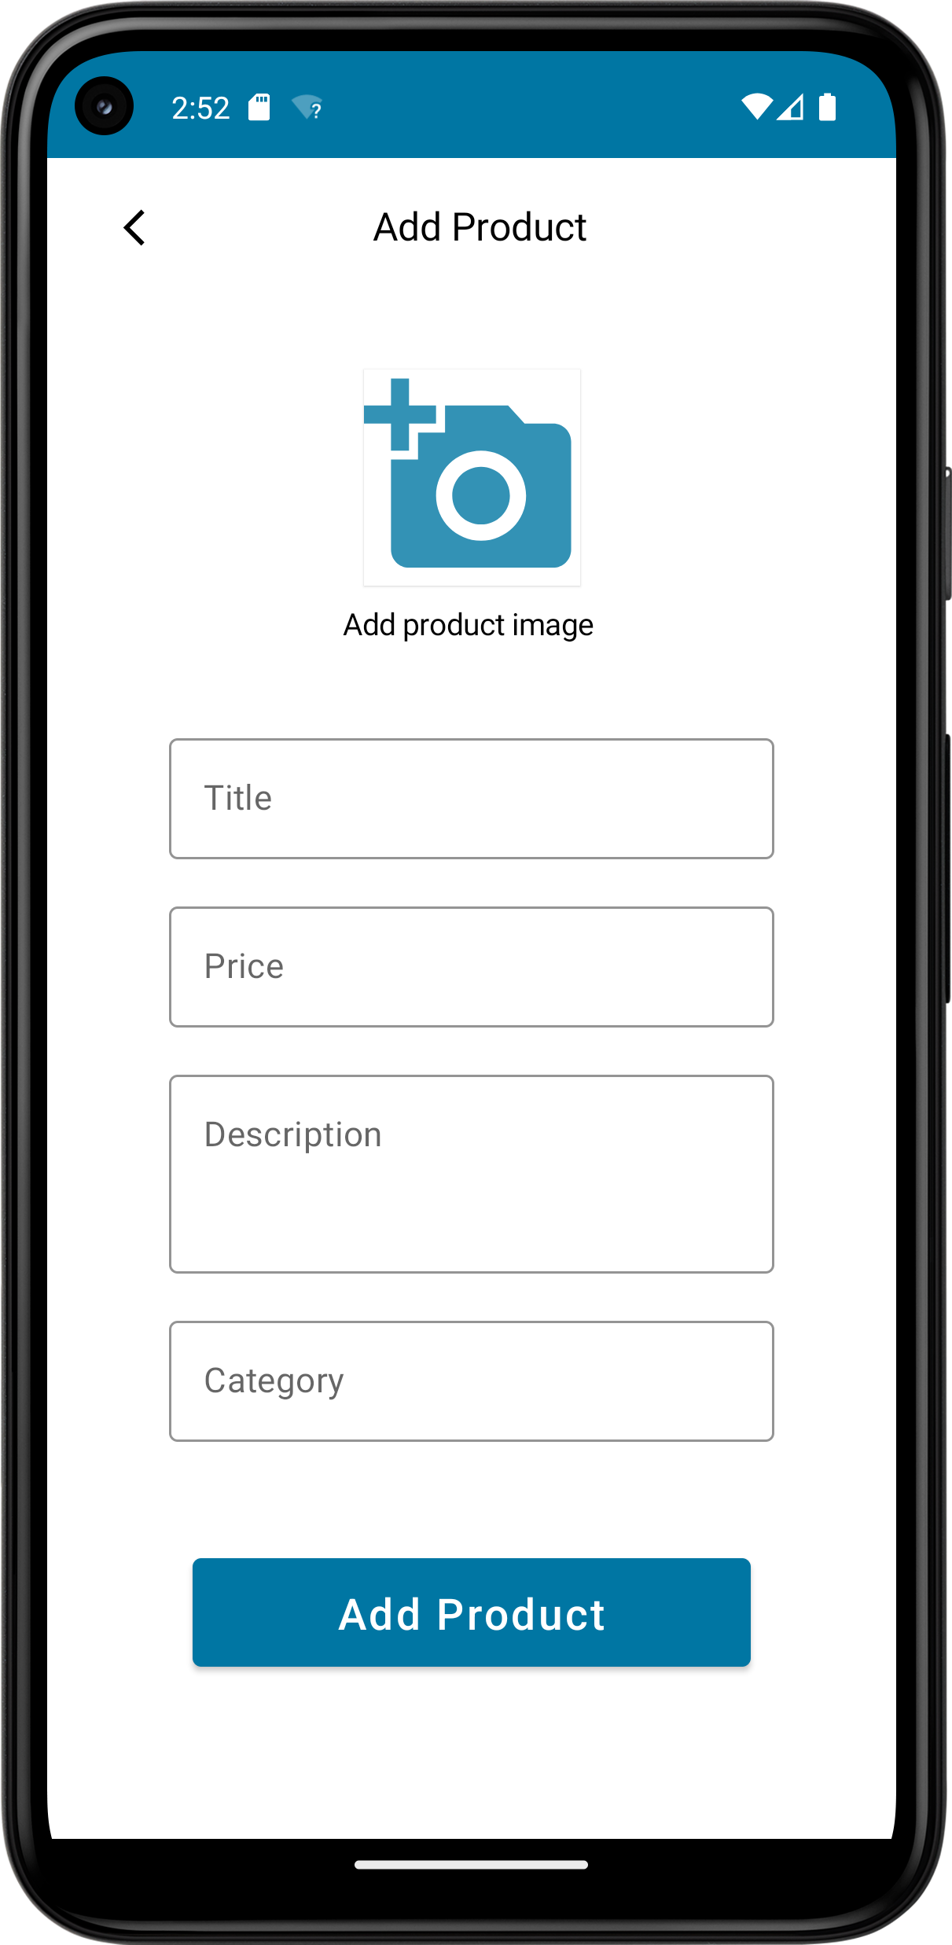

Figure 27.Add Product Screen

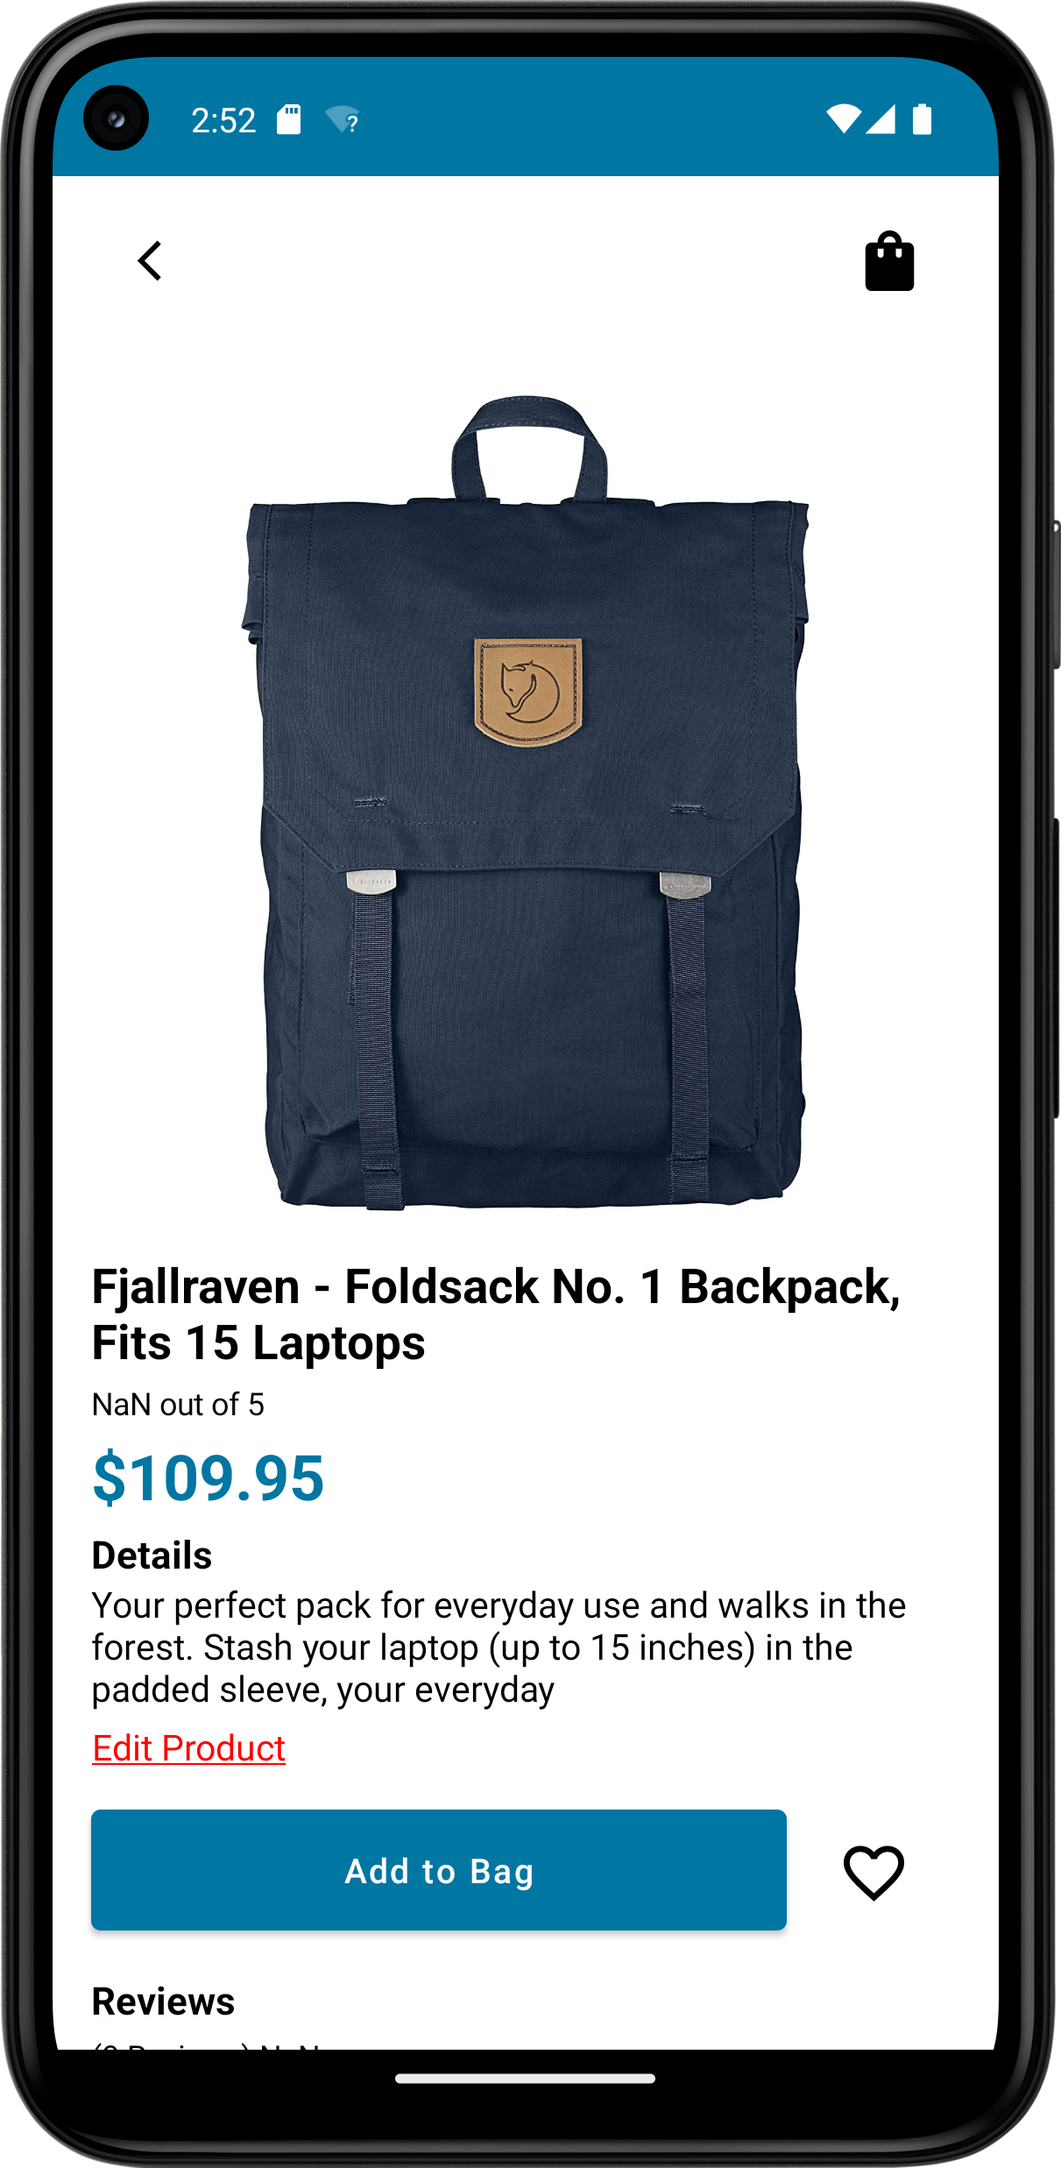

Figure 28. Admin Product Details

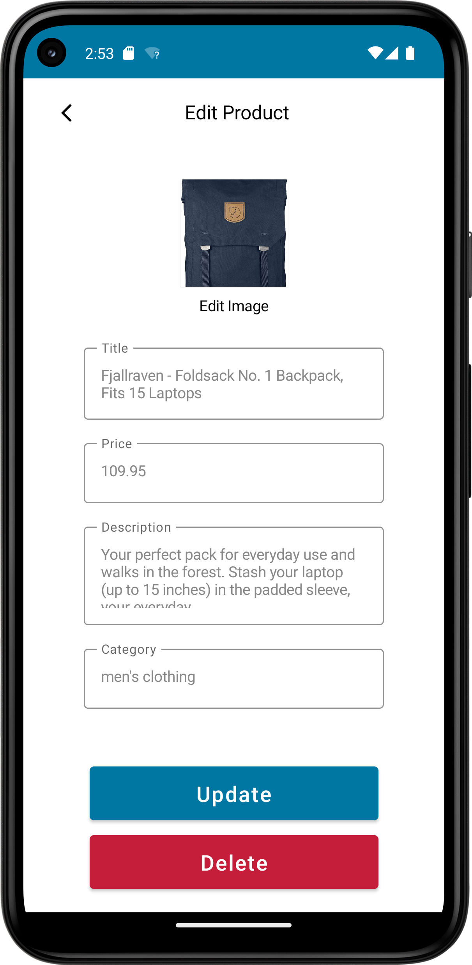

Figure 29. Edit Product Screen

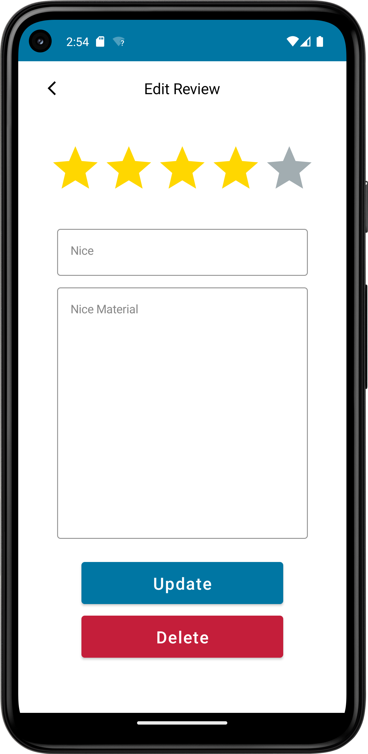

Figure 30. Edit/Delete Review

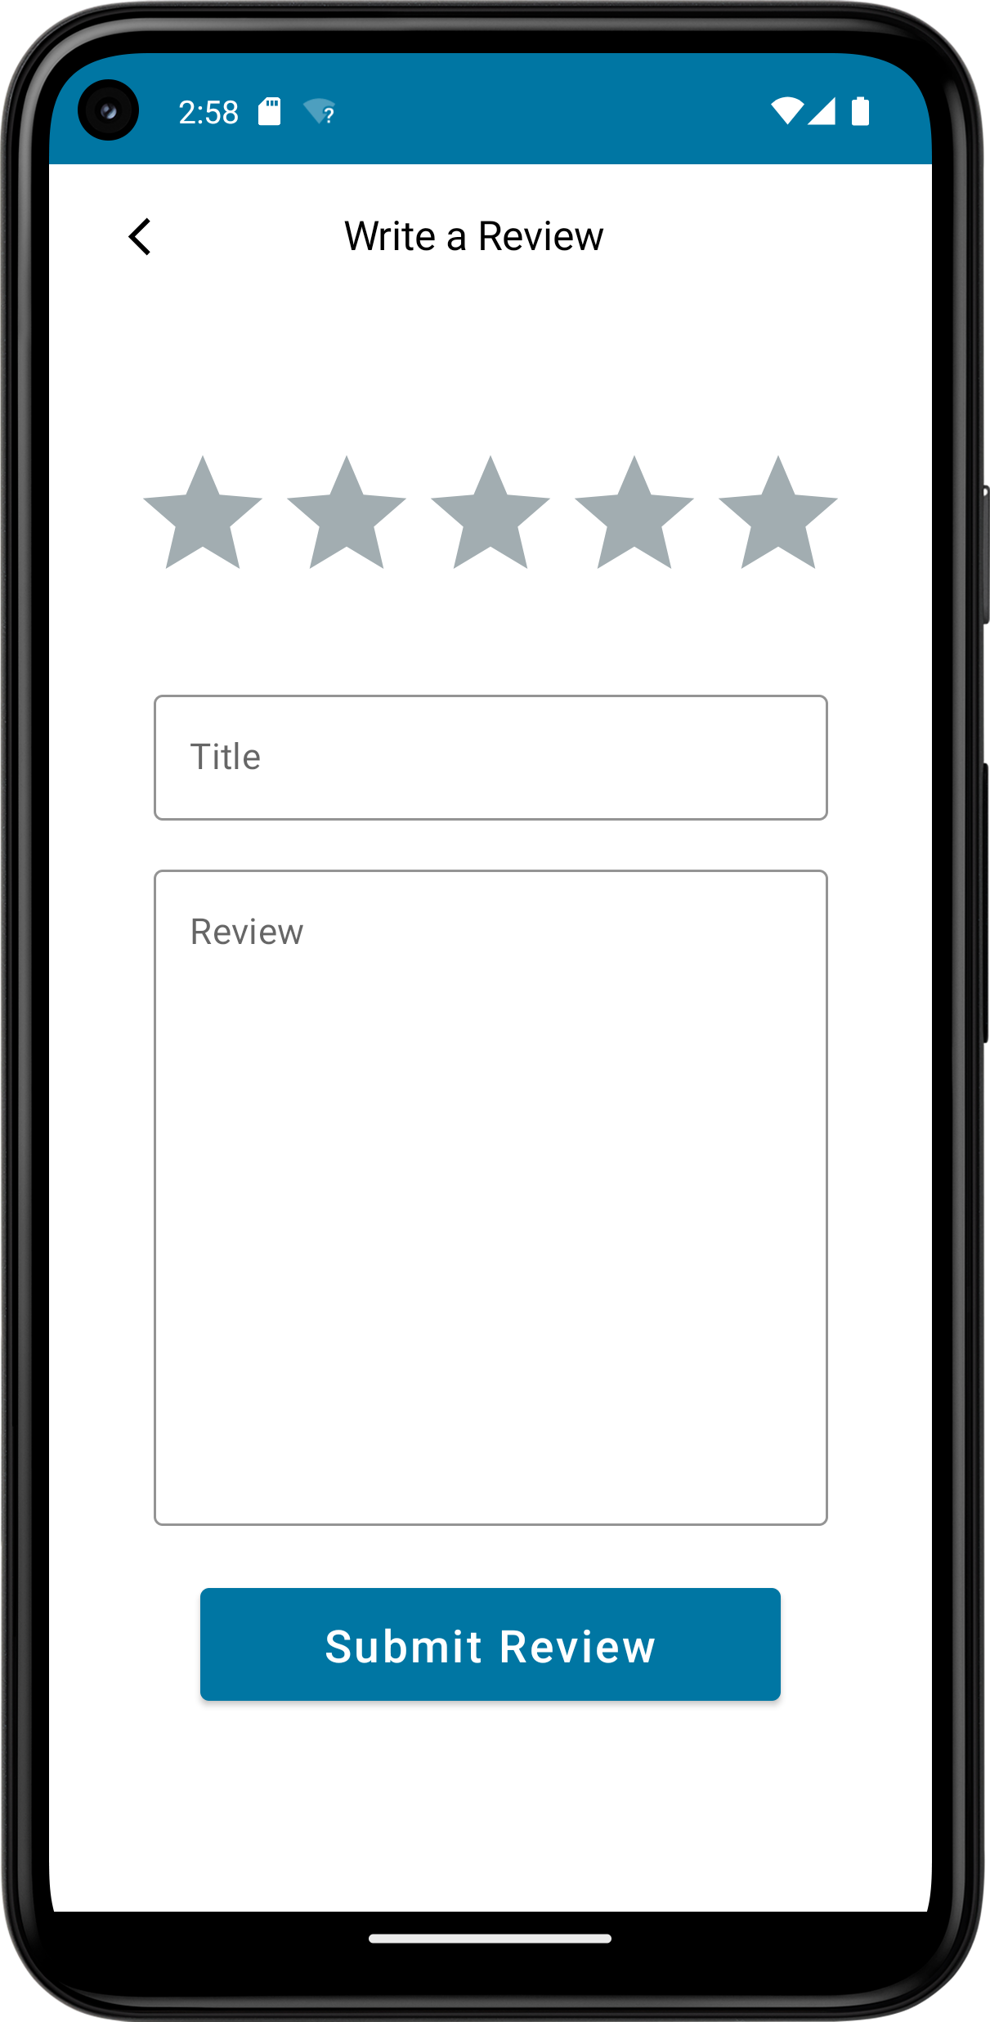

Figure 31. Add Review

Table . list of view items and layouts used to design each screen

|  |  |
| --- | --- |
| Screen Name | View items and layouts used to design the screen |
| Add/Edit Product Screen | * Vertical Scroll * Column & Row * Box |
| Cart Screen | * Lazy vertical grid * Box * Column & Row |
| Home Screen | * Lazy vertical grid * Box * Column & Row |
| Item Screen | * Vertical Scroll * Column & Row * Box |
| Login Screen | * Column & Row * Box |
| Register Screen | * Column & Row * Box |
| Welcome Page | * Column * Box |
| My Orders Screen | * Lazy vertical grid * Box * Column & Row |
| Order Details Screen | * Lazy vertical grid * Box * Column & Row |
| Delivery Screen | * Column * Box |
| Payment Screen | * Column * Box |
| Profile Screen | * Row & Column * Box |
| Edit Profile Screen | * Box * Column |
| Add/ Edit Reviews Screen | * Box * Column & Row |
| Reviews Screen | * Box * Lazy vertical grid * Column & Row |
| Wishlist Screen | * Lazy vertical grid * Column & Row * Box |

# Database Design

To design the database, firstly we used visual paradigm to make an ER (entity relation) diagram. At first we thought of what diagram is best to use ER or EER diagram but considering the tasks that we have we wanted a simple diagram that describes our database in an easy to understand way. Hence, we used ER instead of EER as EER diagram provides a lot of details that we think we do not need.

For the ER diagram, we created two diagrams. An initial diagram that we did not completely follow and the final diagram that describes our now existing database. The initial diagram is shown in Figure 5 and the reason we did not follow this diagram thoroughly is because when writing the code we realized we wanted to add more features and that there were some required features that are not included in the diagram.

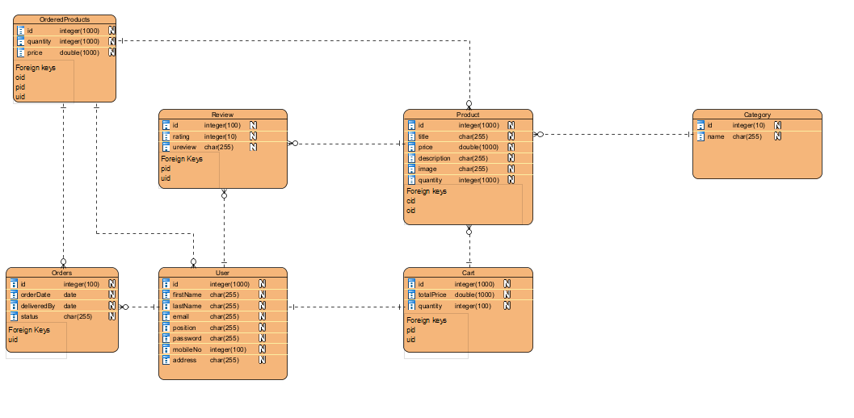

Figure 32.Initial ER Diagram

After recreating the ER diagram, we added more of the requirements such as delivery and payment. Other than the requirements, we figured we can add some additional features so we added a wish list so the user can like the products he considers buying. After adding the additional features the diagram looks much neater and makes a lot more sense. The final Diagram can be viewed in Figure 6.

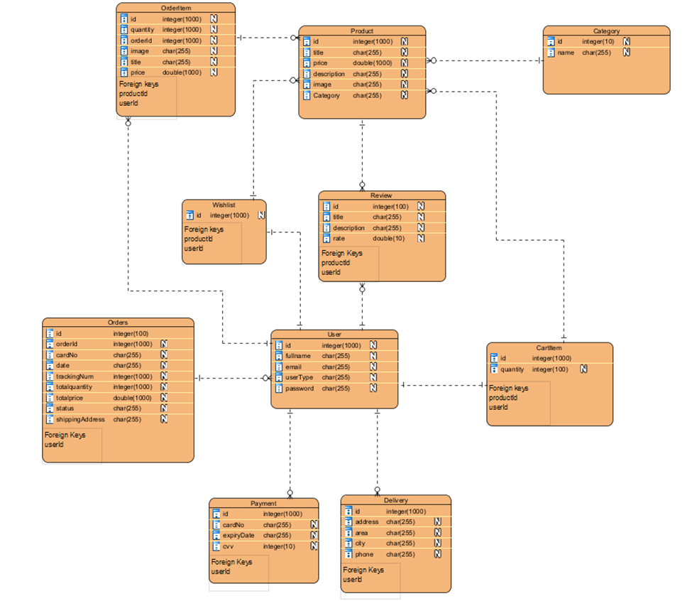

*Figure 33. Final ER Diagram*

# Design and Architectural Patterns

For the patterns choices that we had in mind are façade pattern and creational pattern. Façade Pattern offers a simplified interface to a framework, library, or any other complex set of classes, the use of the facade design pattern has some disadvantages. Because of its central role, the implementation of a facade is a tedious and complicated task, especially if it must be inserted into existing code.

Concerning Creational Pattern, it is used to build an object without demonstrating the procedures or reasoning required to make it. Therefore, you do not need to instantiate the object by using the new operator every time you want it. As a result, this makes the development of objects simpler and more straightforward. Builder, Singleton, and Dependency Injection are a few instances of Creational Patterns. The biggest disadvantage of this approach is that it could be necessary to create a new subclass only to update the product's class. Such modifications may cascade.

The design we adopted is MVVM (Model View View-model). MVVM is the ultimate architecture design used in industries as it overcomes the drawbacks of MVC and MVP design paradigms. MVVM architecture includes a Model where the program’s logic is stored, which the View-Model accesses after receiving the user's input via View. The view contains the displayed user interface which receives input from the user as well. The View-Model lies among the view and model levels, it also controls the interaction with the view and UI elements.

We chose the MVVM model as it has many benefits such as:

* Allows for collaboration as each team member can work on different parts of the project.
* MVVM is easy for separate unit testing.
* Easily change the frameworks.
* The components can be easily reused through the development.

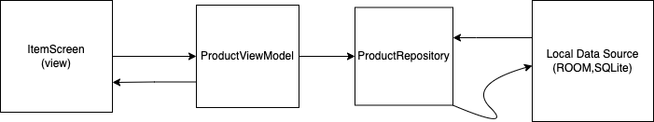

Figure 33: MVVM design pattern (product example)

In the following figures it’s shown how the MVVM design was adopted in our project for the product entity. The same pattern was used for all entities.

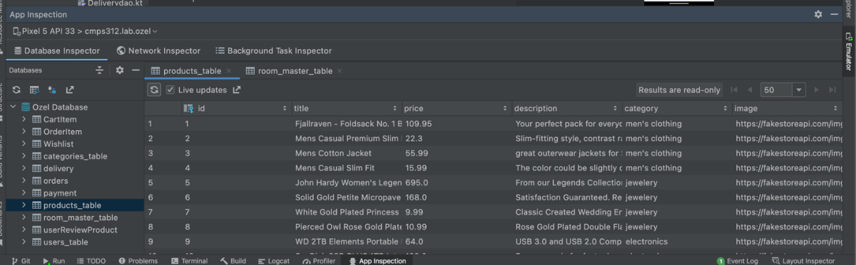

Figure 34. Local Data Source (Products Database)

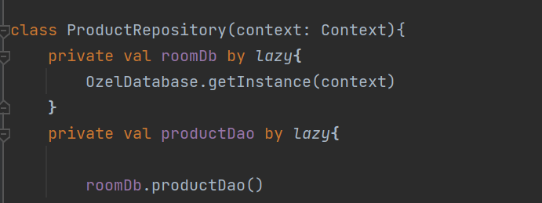

Figure 35. Product Repository

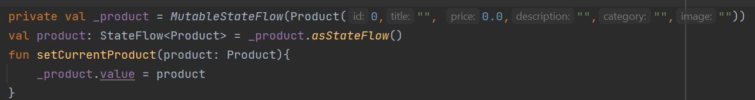

Figure 36. Product View Model

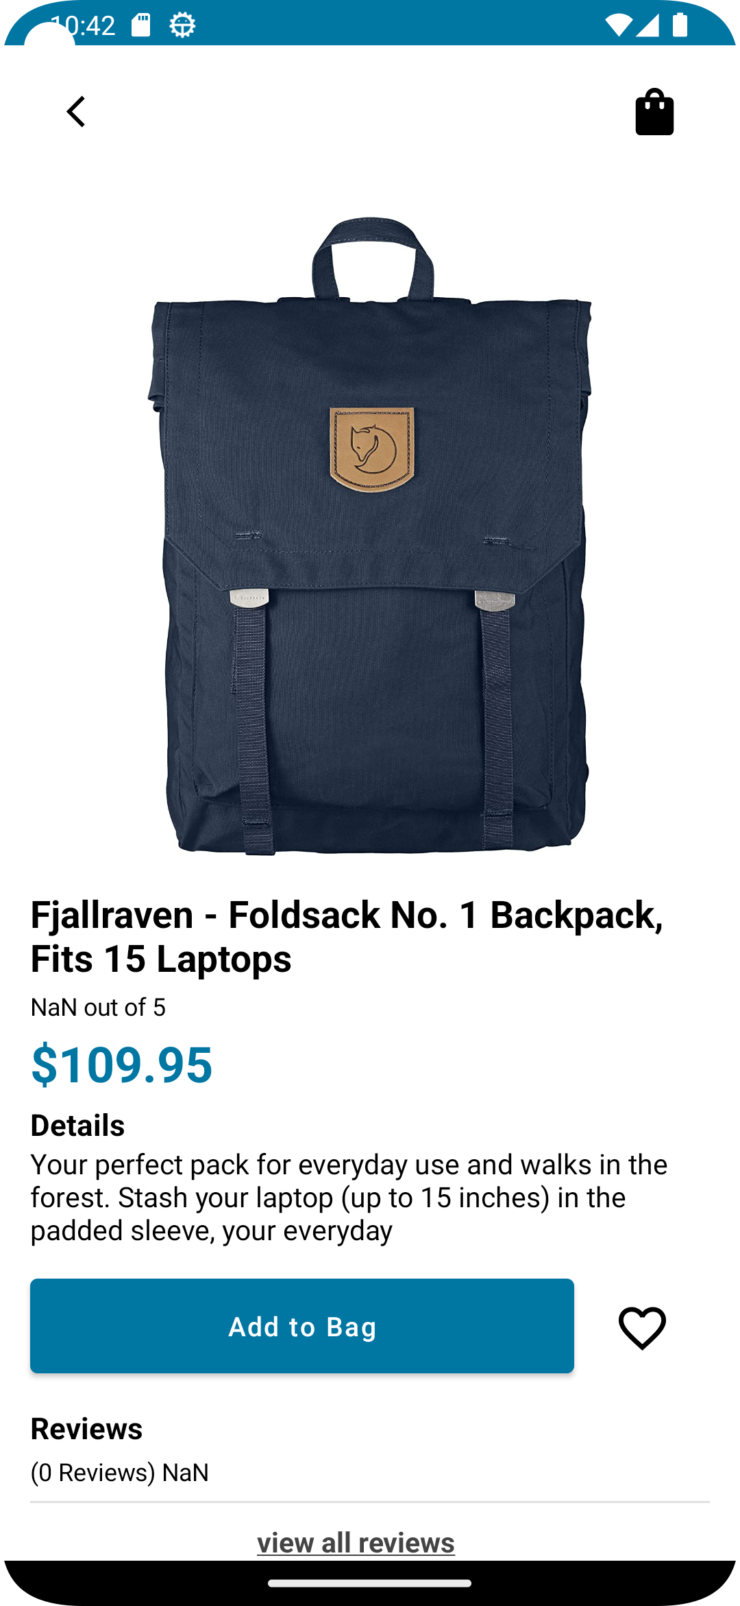

Figure 37. ItemScreen (View)

# Implementation

For our application we tried our best to think about every possible scenario. For example, for the cart, Wishlist, search, reviews, and orders they all have an image that is displayed if there was nothing to view. Moreover, when placing an order, the delivery, payment and ordered items are not added to the database unless the user placed the order in the payment screen as sometimes customers change their mind so we made sure that nothing is saved in the database unless the place order button is clicked. Furthermore, we made sure to inform the user exactly about what is missing, as seen in the figures below the user is notified what field exactly is stopping them from going to the next step. Also, temporary notifications pop up to confirm the addition or removal of items from the wish list or the addition of a product to the cart. Finally, the user can edit their reviews from the item screen reviews or from “ My reviews” in the profile screen.

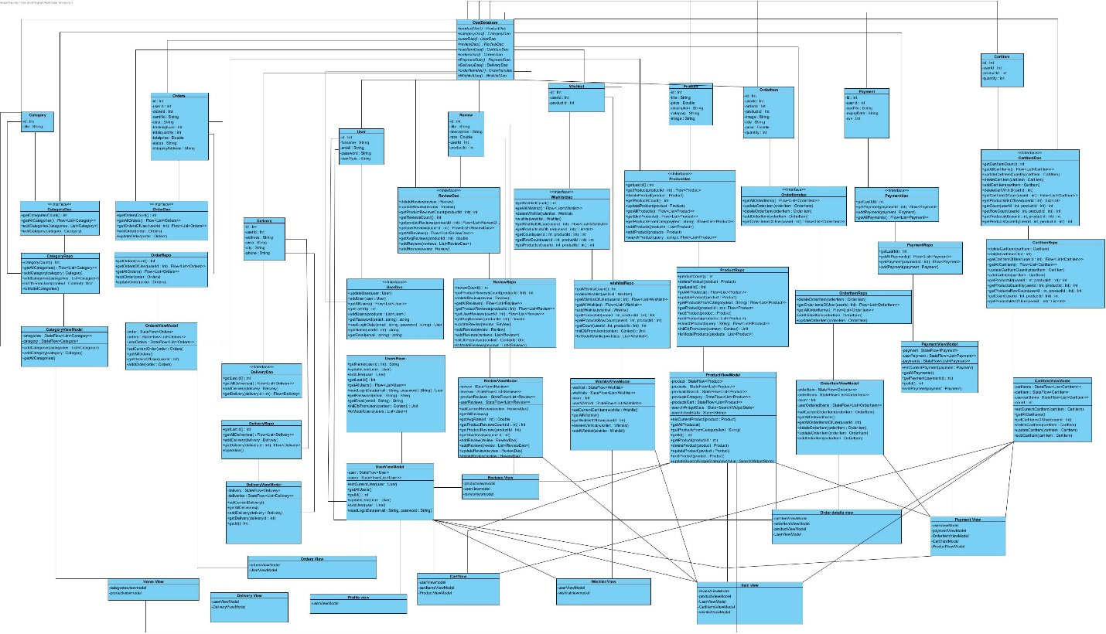

**Use Case 1 – Login**

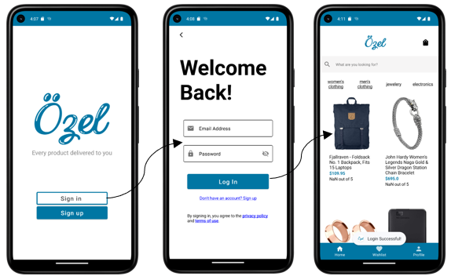

Figure 38. Use Case 1 – Login Demo

The user can log in to the System by clicking on the sign-in button on the welcome page which navigates to the login screen. At the login screen, the user enters their email address and password. If the email and password match and the email exists in the database the user is then navigated to the home screen. However, if the user entered an email that doesn’t exist or the email address or password text field is empty or the password is incorrect a temporary notification will pop up to notify the user.

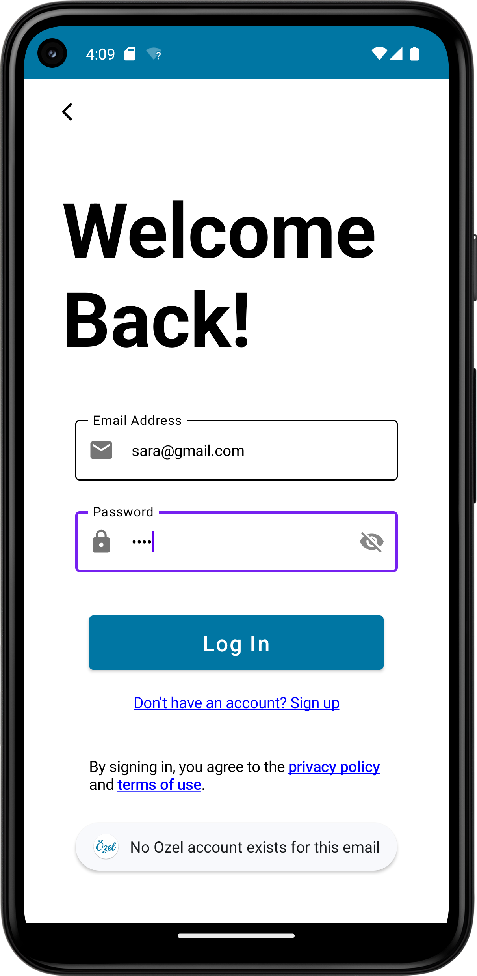

Figure 39. Email does not exist Notification

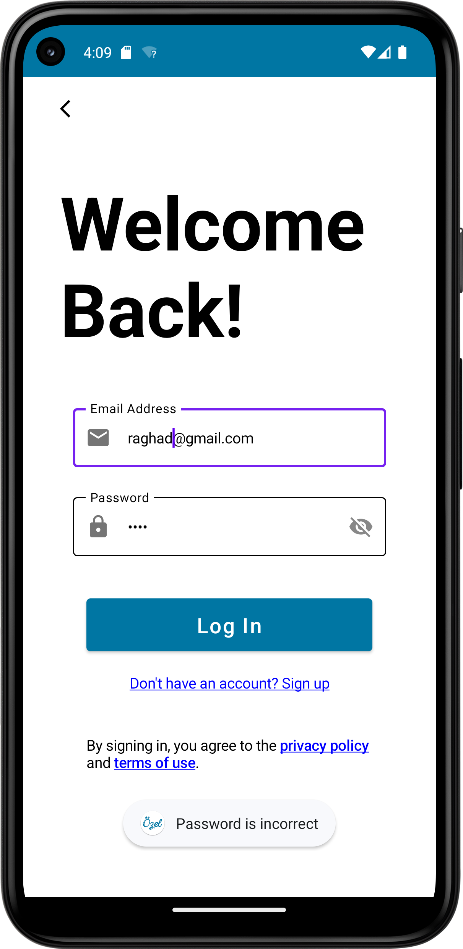

Figure 40. Incorrect Password Notification

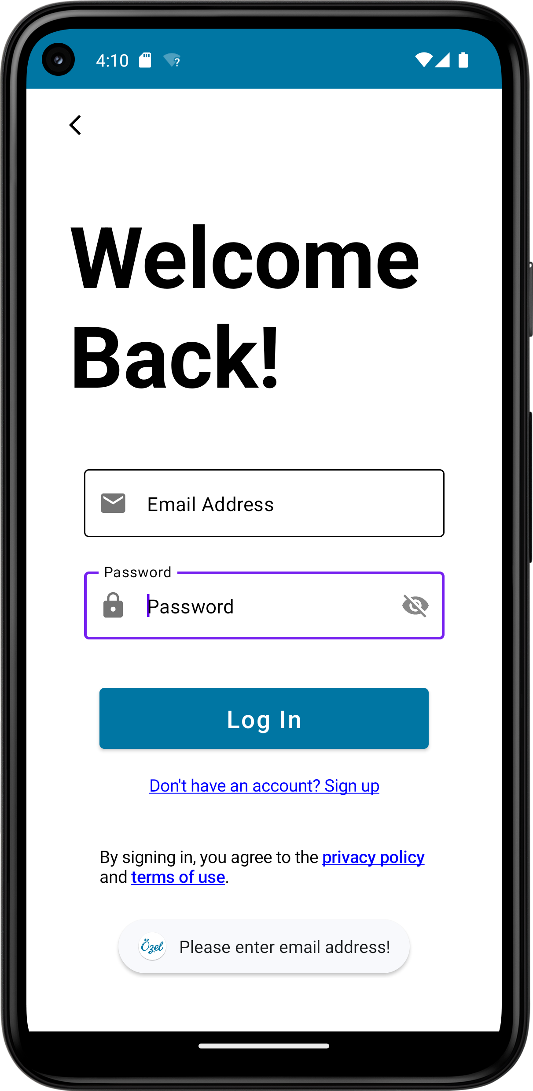

Figure 41. Email Address Text Field is empty Notification

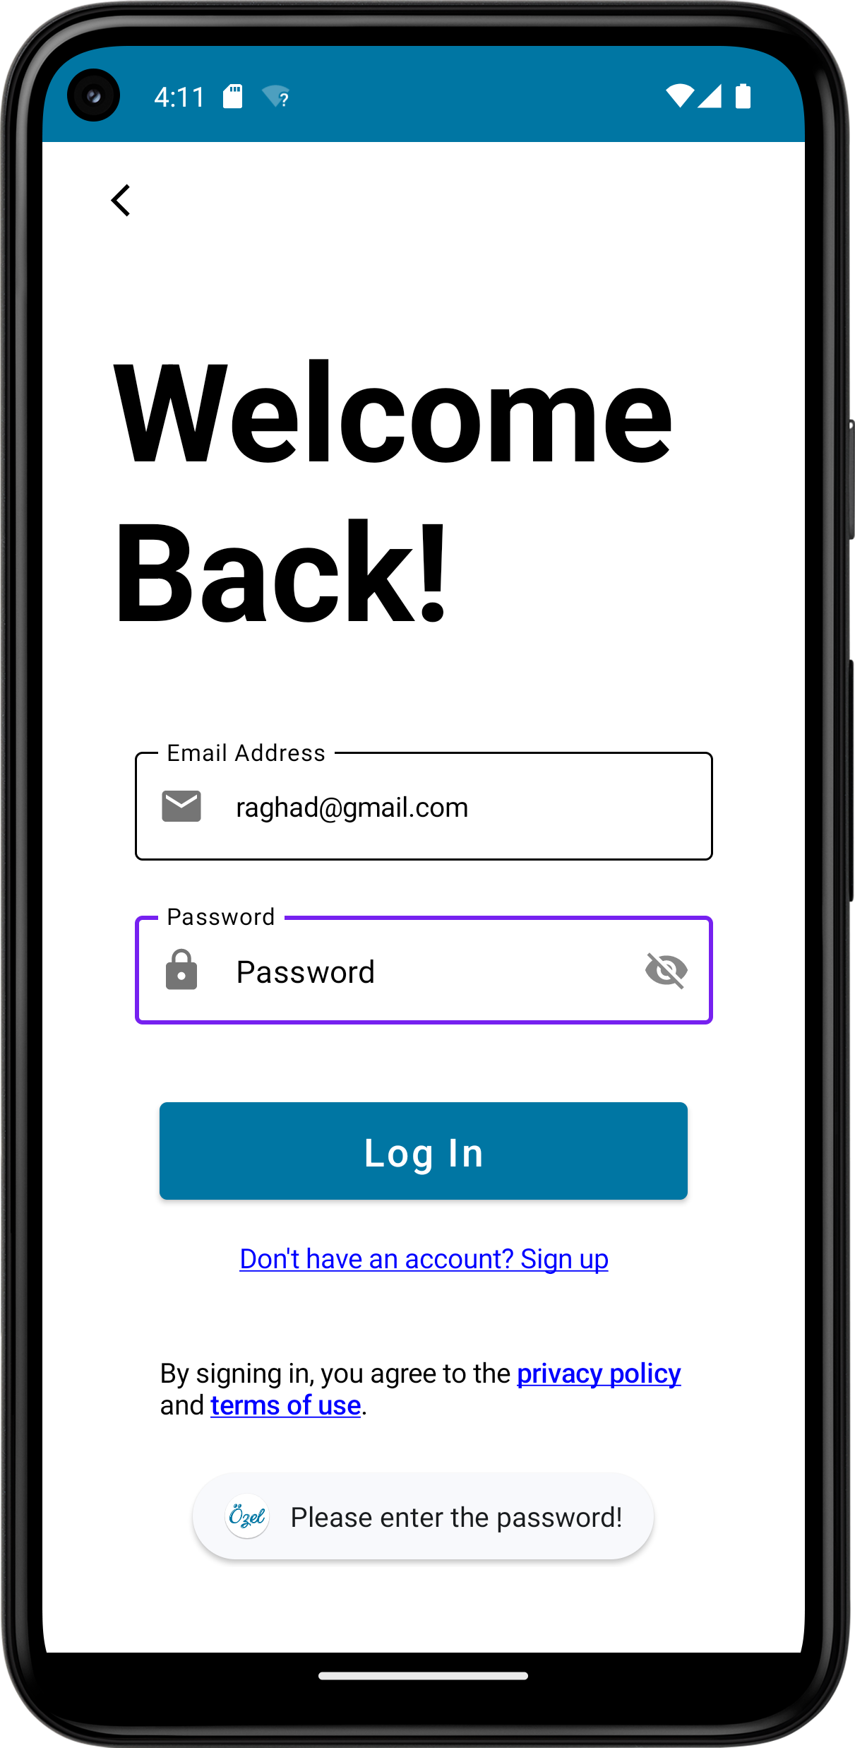

Figure 42. Password Text Field is empty Notification

**Use Case 2 – Register**

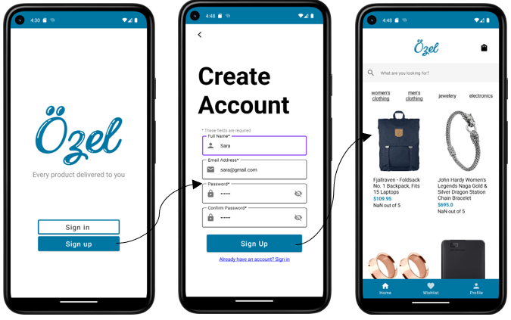

Figure 43. Use Case 2 - Register Demo

The user can register to the system by clicking on the sign-up button on the welcome page which navigates to the registration screen. At the register screen, the user needs to enter their name, email, and password. The system checks if the email exists in the database if it does not the user is registered to the database and navigated to the home screen. However, if the email exists in the database or the password confirmation and password don’t match or if any of the fields were empty a temporary notification will pop up.

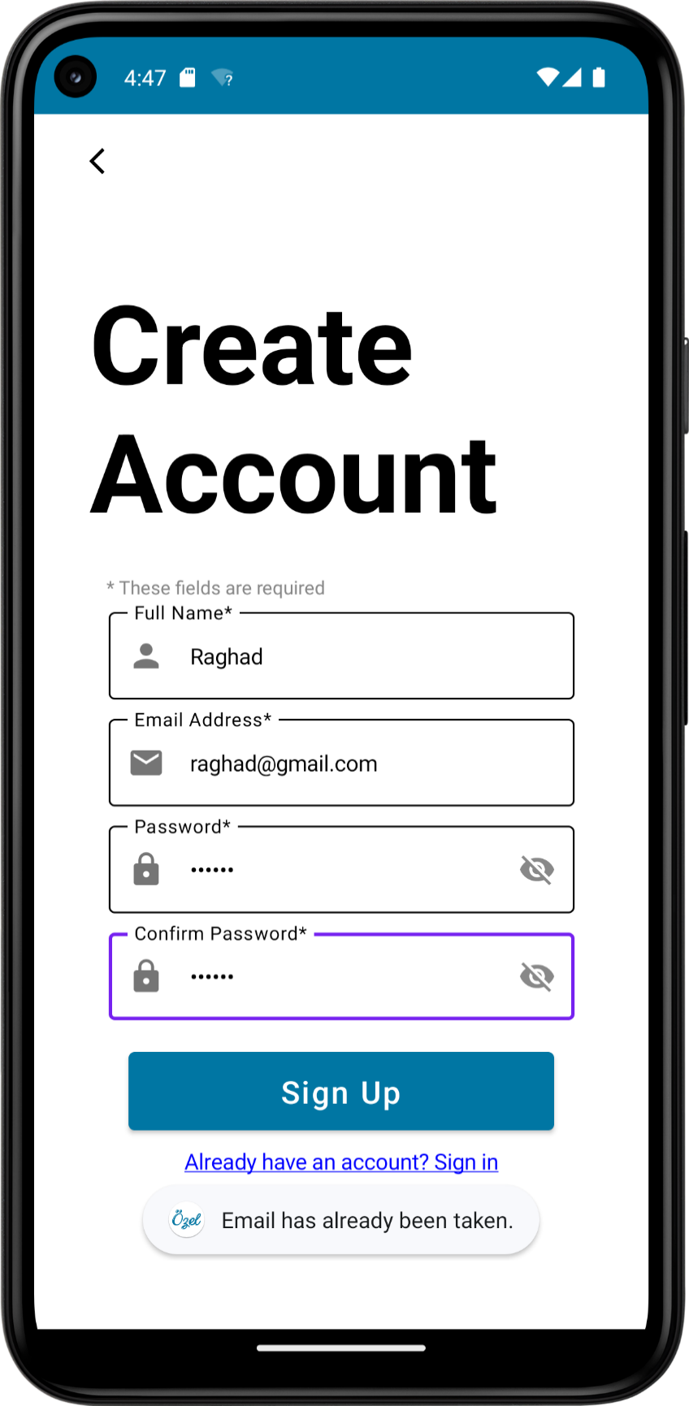

Figure 44. The email has already been taken Notification

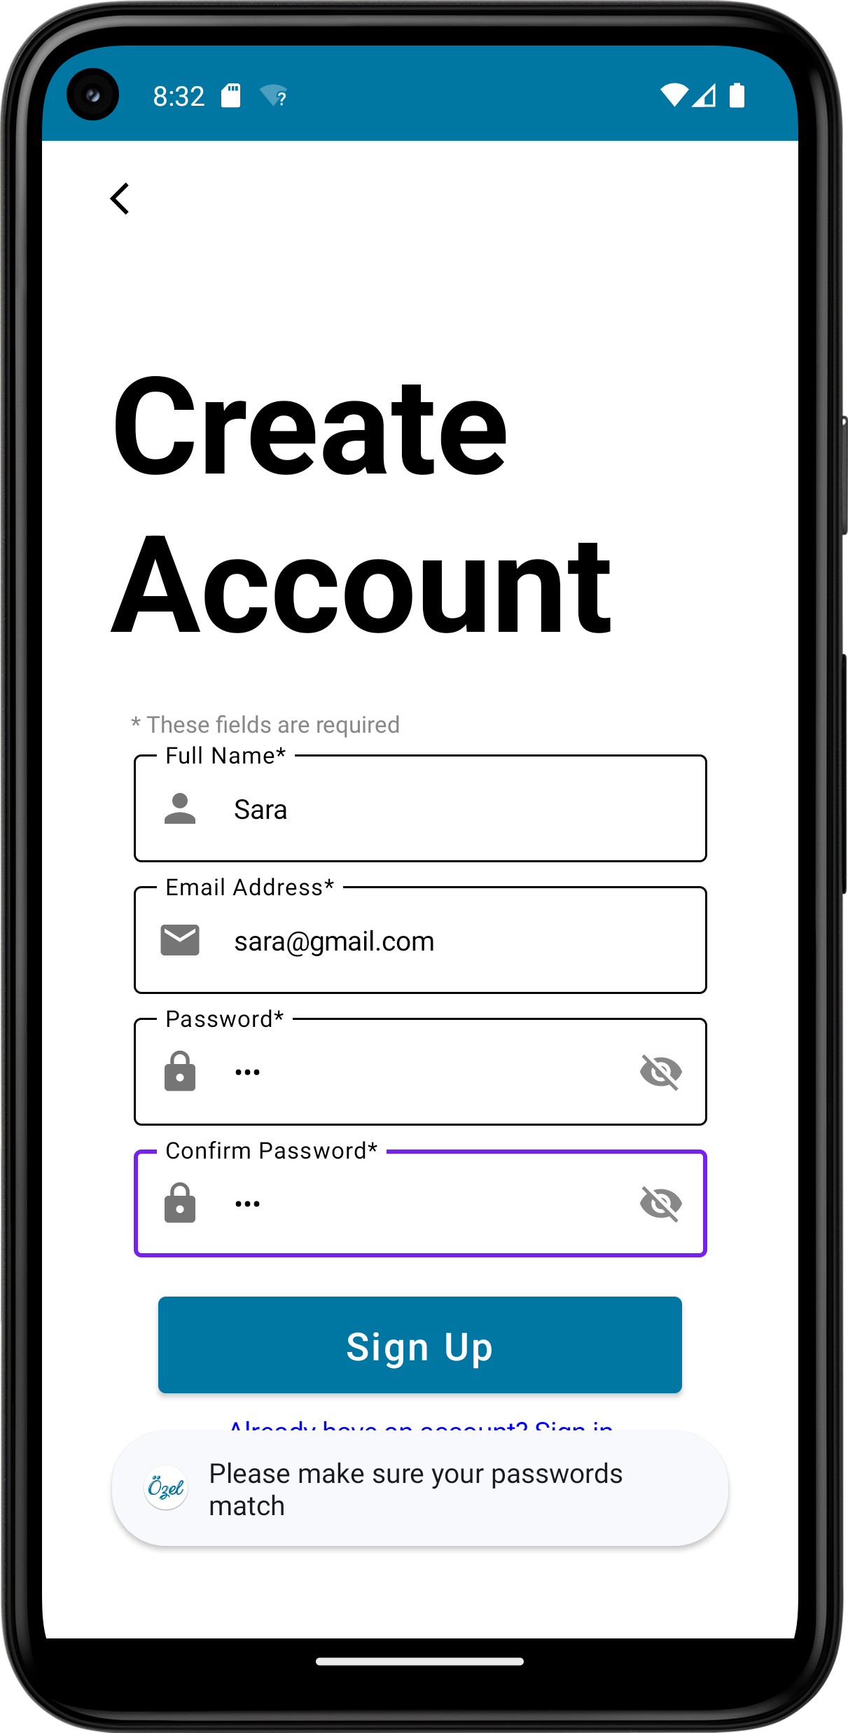

Figure . Passwords doesn't match notification

**Use Case 3 – View Products**

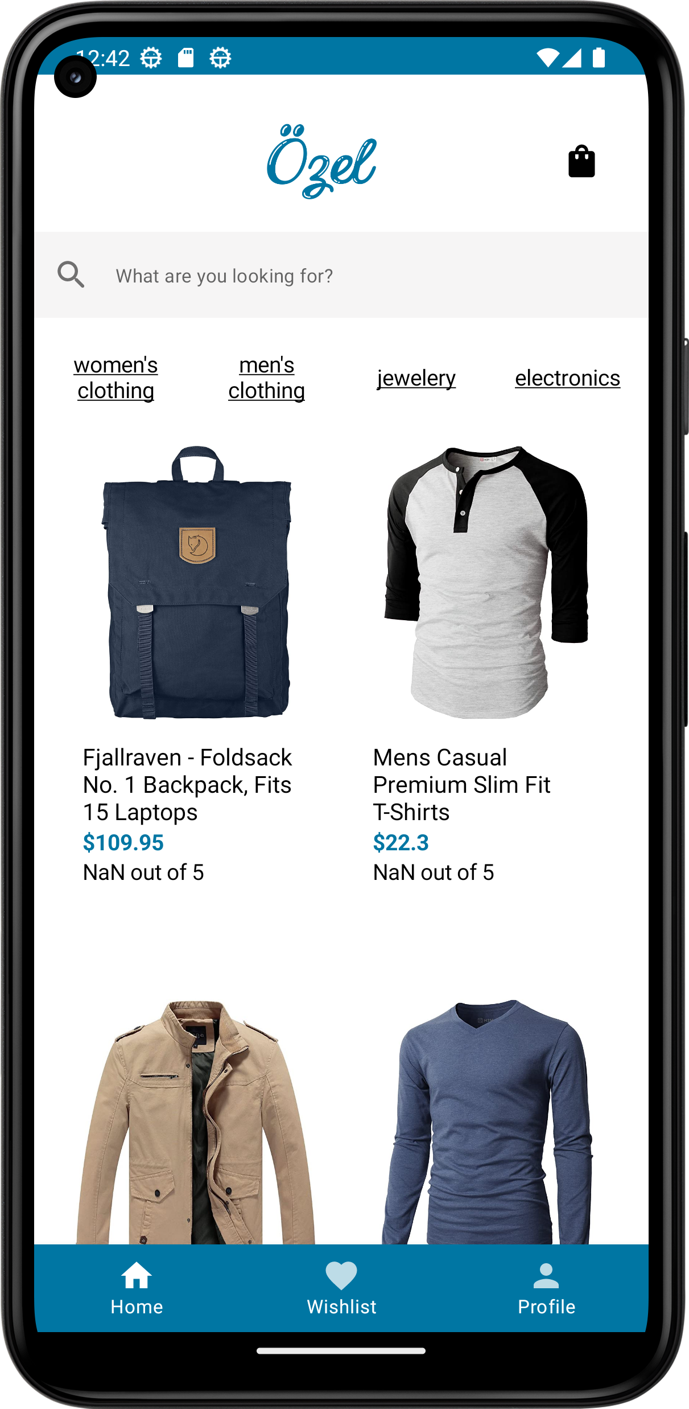

Figure . View list of available products

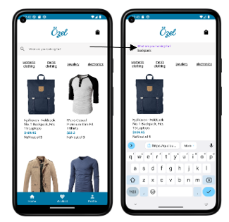

Figure . Search products

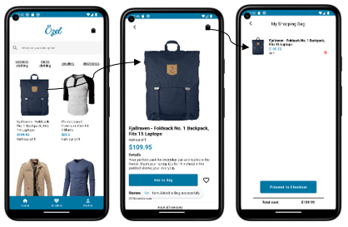

Figure . View product details & add product to cart

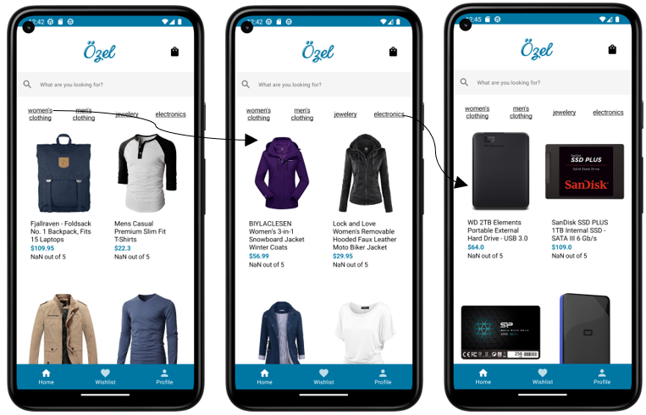

Figure . Filter products

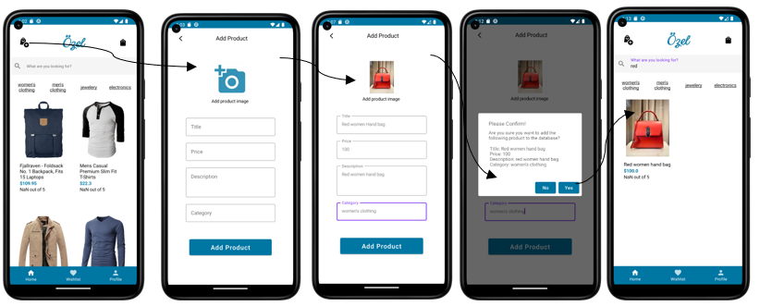

Figure . Admin Add product

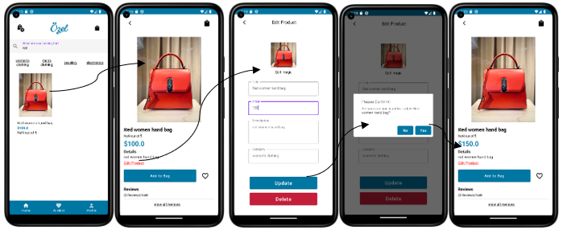

Figure . Admin edit product (price)

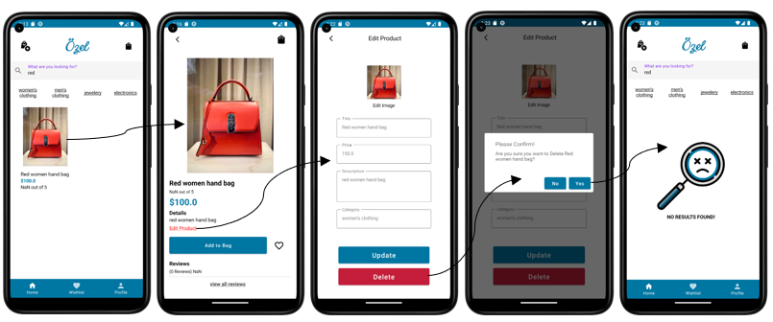

Figure . Admin delete product

For the view products use case, the user can view all the available products as seen in figure 46 on the home page. Then they can use the search bar to search for any product in the database as seen in figure 47. The user can then click on any of the products then they are navigated to the items screen where they can know more about the product and add it to the bag as seen in figure 48. The user can also filter products by clicking on any of the categories as shown in figure 49.

As shown in figures 50, 51, and 52 the admin can add, edit, and delete products. For the add, the admin should click on the shopping bag with the plus sign icon on the left side of the top bar to add any product to the database. As for the delete and update the admin has to click on the item they want to edit or delete then click on the edit product in the item screen which navigates to the edit product screen. The add product and edit product buttons only appear if the user type is admin.

**Use Case 4 – Cart**

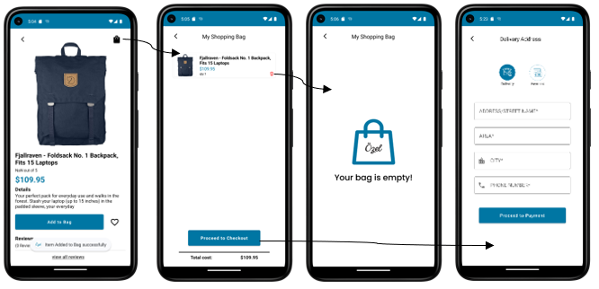

Figure 53. Use Case 4 - Cart Demo

The user can add items to their shopping bag through the item screen. Once the product is added a confirmation notification will appear to confirm that the product was added. If the user clicked again on the same product the quantity of the product will increase. The user can then access the cart by clicking on the shopping bag icon which navigates to the shopping bag screen. In the shopping bag screen, the user can delete the products in the cart by clicking on the garbage icon or proceed to checkout by clicking the button at the bottom of the screen which they are then navigated to the delivery screen. If there are no products in the cart an image will appear indicating that the user’s bag is empty!

**Use Case 5 – Orders**

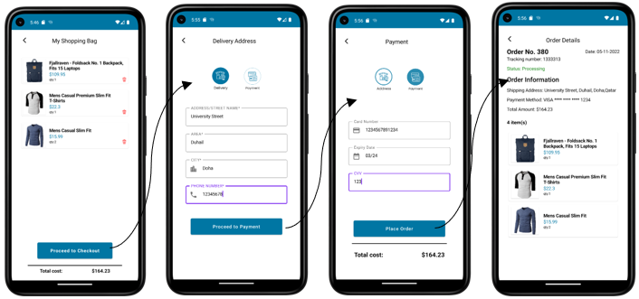

Figure 54. Use Case 5 - Orders Demo

Once the user added the products to their shopping bag and clicked on the proceed to checkout button, they are then navigated to the delivery screen where they enter their delivery address details. After the user enters their delivery information and clicks on the proceed to payment button, they are then navigated to the payment screen where they enter their card information. After they click on the place order button, they are navigated to the order details screen. The order details screen includes a summary of what they ordered, delivery address, payment method, and more.

The shopping bag screen includes the quantity of each product, its price, and the total price of the order. Also, for delivery address and payment details, a notification will pop up if one of the fields was left empty.

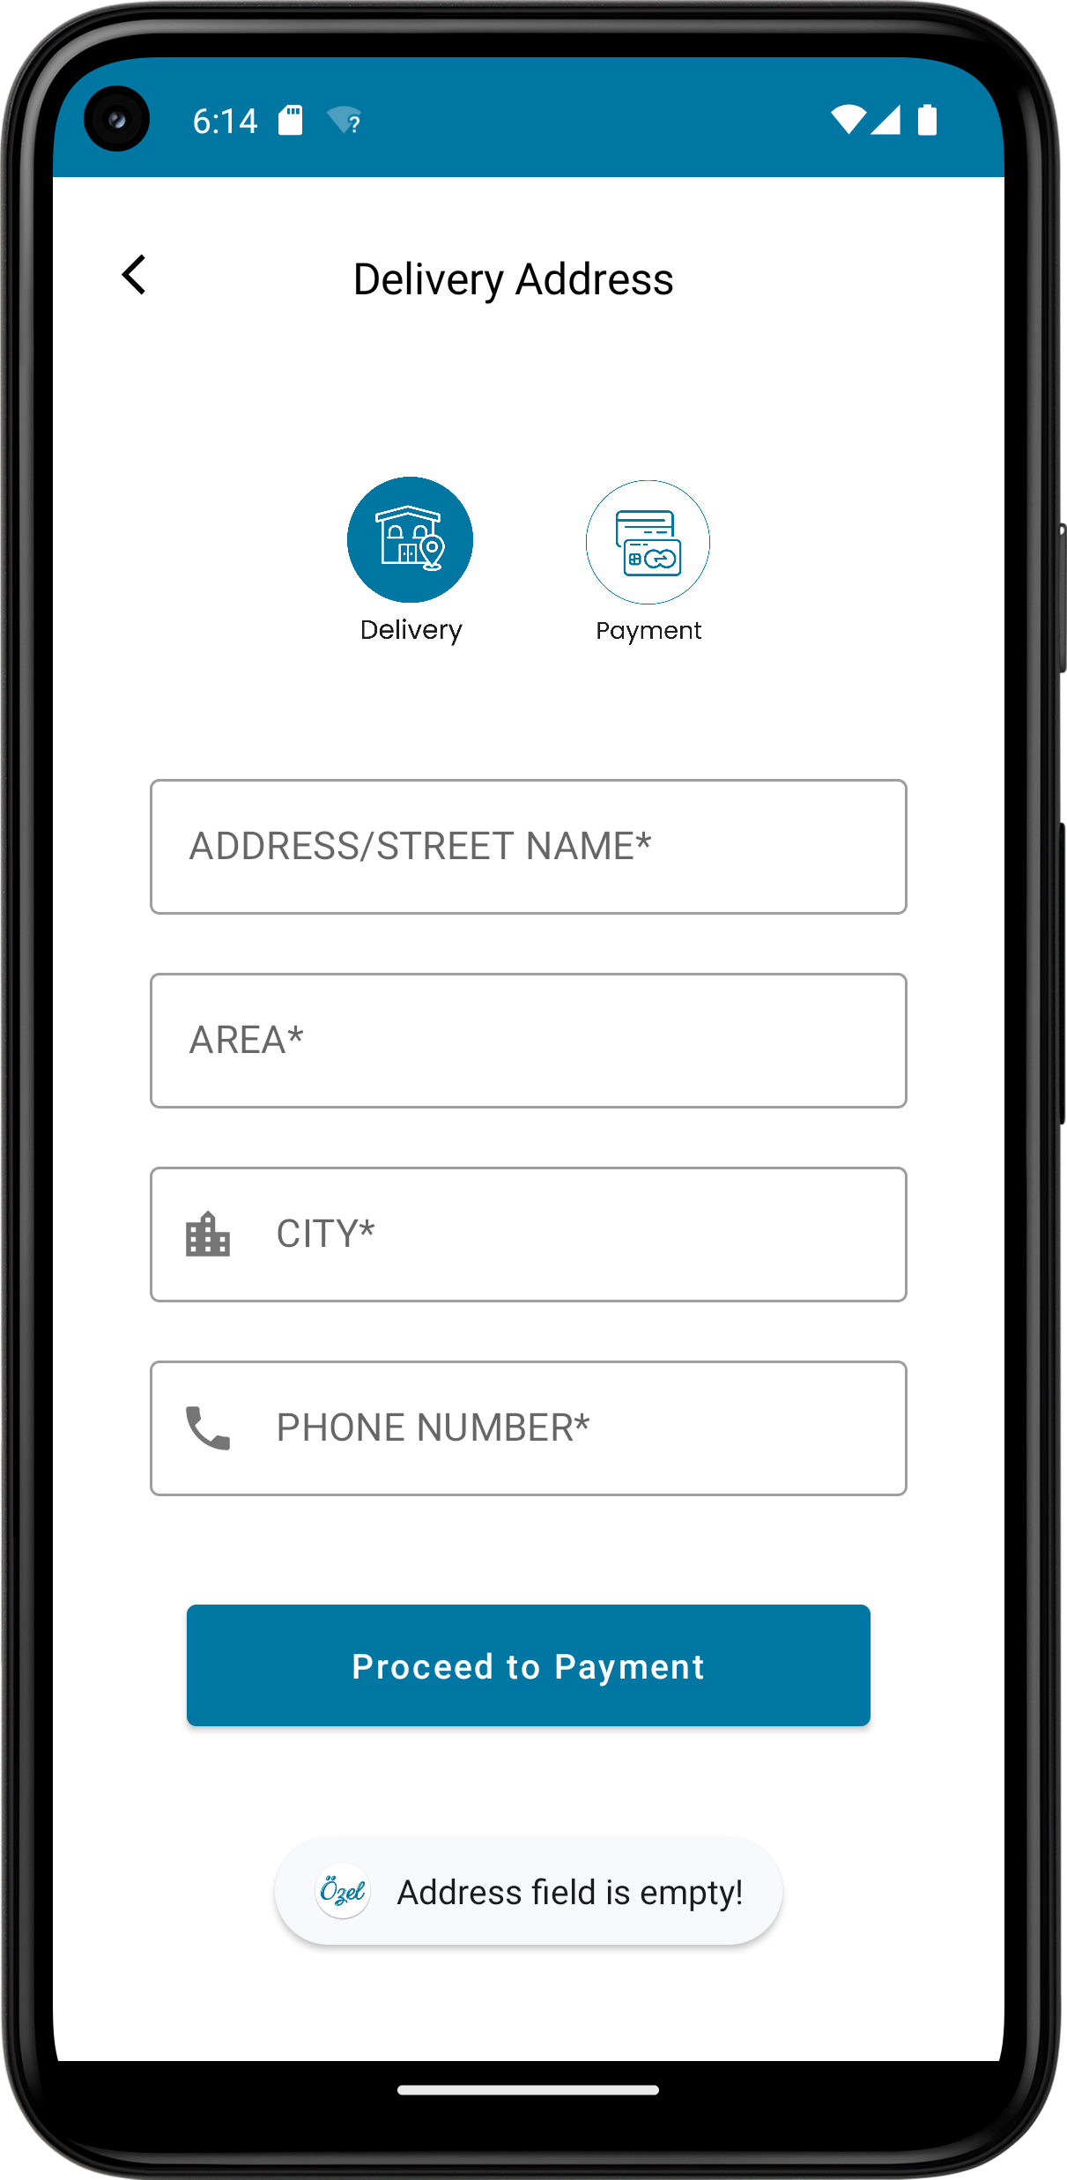

Figure 55. The address field is empty Notification

**Use Case 6 – Reviews**

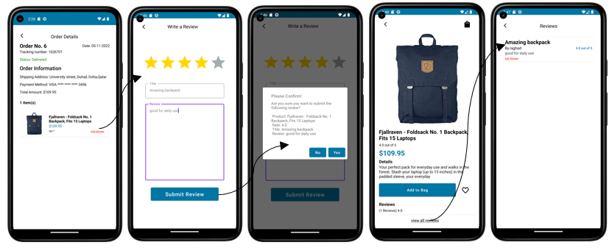

Figure . Add review

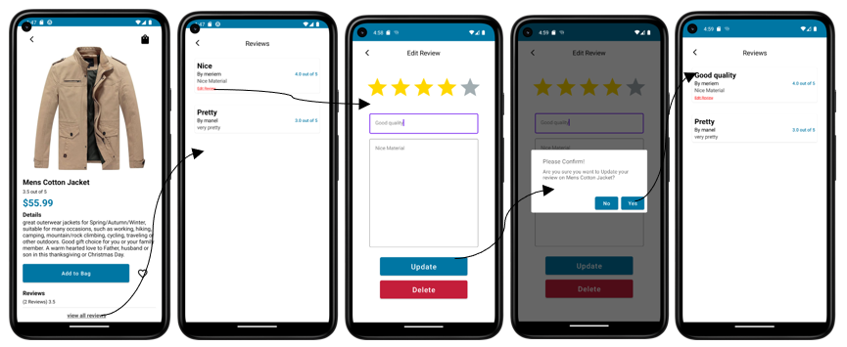

Figure . Edit Review Demo

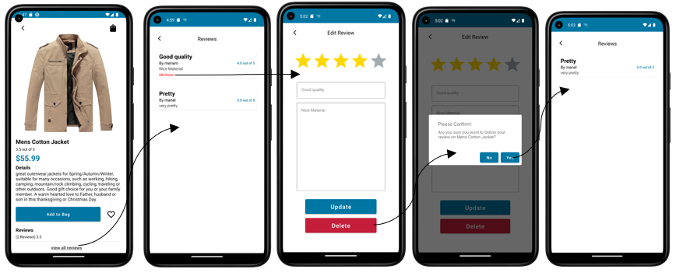

Figure . Delete Review Demo

For the add review, as seen in figure 56 once the order is **delivered** the user can add their review through the order details screen by clicking on the add review button.

For the edit review, the user can edit their review either through their profile by clicking on mu reviews or via the item screen by clicking on “view all reviews” which navigates them to the reviews screen and if the review was written by the user “edit review” will appear on the review card. Once clicked on the “edit review” the user can update their review or delete it as seen in figure 57 and 58.

# Additional Features

1. **Wishlist**

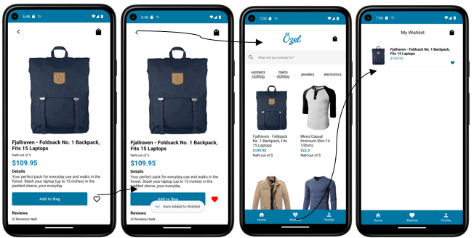

Figure . Add to wishlist

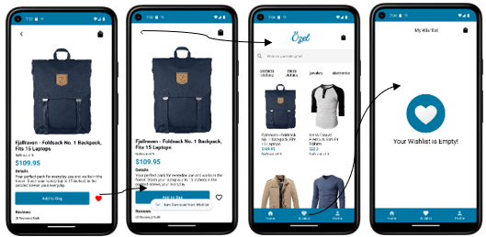

Figure . Delete from wishlist #1

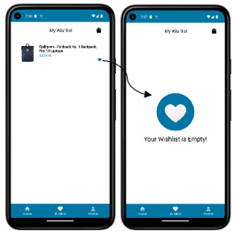

Figure . Delete from wishlist #2

As shown in figure 59 the user can add items to the wishlist by clicking on the heart in the items screen the empty heart turns to red indicating that the product is in the wishlist. The user can then access the wishlist through the bottom bar. There are two ways to remove a product from a wishlist. The first way as shown in figure 60 the user clicks on the red heart which changes to an empty heart indicating that the item was removed from the wishlist. The second way is from the wishlist it self by clicking on the blue heart the item is removed from the wish list as shown in figure 61.

1. **Profile**

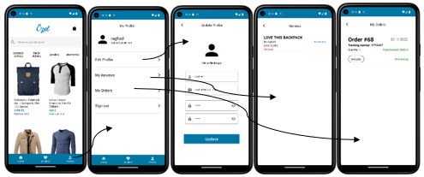

Figure . Profile Demo

The user can access their profile by clicking on the profile icon in the bottom bar where they are then navigated to their profile screen where they can update their profile information, check their reviews for any product, check their previous and current orders and sign out.

1. **If there is no data to view**

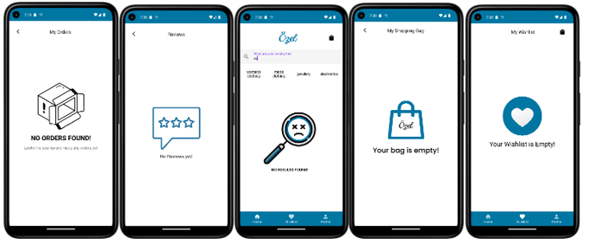

Figure . Images if there is nothing to view

As seen in figure 63, a special feature in our application that if there is nothing to view, depending on the screen, an image will show.

1. **Orders**

# 

Figure . My orders Demo

As shown in figure 64, the user can check their previous and current orders by clicking on “my orders” in the profile screen. Once clicked they are navigated to a list of all their orders. If the user wishes to know more about the order, they click on the “details” button where then they are navigated to the order details that has all the information relevant to the order.

# New Gained Knowledge and Skills

**Manel Riahi:**

* Being introduced to adobe XD and getting familiar with how it works [1]
* Getting familiar with Canva and find inspiration for the logo [2]
* Learning the kotlin programming language + Kotlin OOP [3]
* Understanding jetpack compose to build a reactive UI (user interfaces) [4]
* Learning the benefit and use of MVVM patterns
* Data management using SQLite and Room
* Debugging errors using the website stack overflow
* Getting familiar with Android studio as an IDE and effectively using the emulators
* Using Firebase Cloud Services: Firestore, Cloud Storage & Firebase Authentication

**Raghad Aqel**

* The importance of brainstorming and market research before designing the end product .
* The amount of time, effort, and skills needed to create an application.
* It’s not that easy to bring your design to code. It needs patience.
* The importance of the word “Serializable” for the entity and database class.
* How to connect entities, repositories, view models and views
* Jetpack compose
* How a minor issue as simple as missing one word can crash the program.
* Most of the time the app crashes as entity attributes were updated not because there is an error.
* Learning Kotlin is easy

**Meriem:**

* The design process is very important as it is the base that we refer to during the development, we used adobeXD to design our application.
* Learning the new coding language Kotlin through its documentation.
* Implementation of the project by the MVVM architecture method.
* Resolving issues that refer to the emulator and the whole project such as wipe data, clean project and rebuilding the project.
* Setting up the navigation of the screens by having different routes.
* Implementing the room database and retrieving data from it though SQL commands, displaying the required data in the views.
* Recognize where the different errors detected come from as some are linked to the gradle, actual code, rendering the preview and having different versions of android studio.

**Anjoud Al-Romaihi**

* Planning is of more importance than starting coding as it cuts time and reduces efforts. It also makes your mind clearer on what you want to do.
* Every process takes it time.
* Never underestimate a task as it might surprise you.
* Everything can be done given the time and effort.
* The things we want might not be what benefits the user, so user’s view is of most importance.
* How to use kotlin language in making mobile applications on android studio.
* Managing data using Room and SQL queries.
* The internet is filled with lots of information that we can benefit from.

**Islam Hamdi:**

* Working within a team and collaborating between us to achieve a shared goal within a specific time frame was one of the greatest skills I have gained in this course
* I got the opportunity to learn about different software that I can use to design my app and bring it to life before even starting the implementation
* Although I haven’t taken databases yet, I managed to learn different types of queries and the most important SQL commands. I even learnt some fundamentals like a primary key, a foreign key, and how to connect between entities.
* I learnt how to create an Entity Relationship (E-R) diagram to display database relations
* I’ve leart how to make a free privacy URL for our app using online tools like (<https://www.freeprivacypolicy.com>) [8]
* I’ve never used GitHub in any of my previous courses, so I got the opportunity to learn how to use it (how to clone a repo, how to push and pull how to write meaningful description for commits) by getting help from my great teammates
* Sometimes, there might be no errors in the code, but the emulator won’t work because of low storage therefore we need to wipe data out and refresh.
* I learned Kotlin without learning Kotlin. It might be weird but it is true as Kotlin is so similar to Java and the android studio helps to convert codes from java to Kotlin and the syntax is so easy that you can learn it just by seeing a few videos.
* In the altering I faced the most annoying error, and the code did not run every time I try to run it, then I realized that there was a typo in the json file, the p was capital in the json and small in the entity so there was a mismatch which was causing the error for me and that was so frustrating for me. We need to always check syntax before jumping to the conclusion that our code is wrong.
* Pressing control and hovering over the keyword or function or class name will give you the ability to move between the occurrences of that word in all the project, and this hack was so time-saving for me.
* Learned how strong and efficient is the MVVM (Model View ViewModel) architecture pattern for developing apps, that’s why Google recommends it for developers

# Reflections

**Manel Riahi:**

Personally, I think that taking a programming course as PBL experience was successful I enjoyed learning on my own without being obliged to attend classes every day. I learnt how to use resources, how to read documentations and how to properly use any code that can help me proceed in the project. The only thing that was challenging is group work, the more people in the group the more schedules to accommodate, tasks to assign and different points of view to consider. When planned properly, group projects can strengthen abilities that apply to both group and individual work, such as the capacity to divide difficult tasks into parts and steps, manage time, improve comprehension through discussion and clarification, and most important thing group projects can assist in developing abilities related to teamwork, enabling to tackle more difficult issues than being on your own.PBL experience was beneficial , it is actually much more than simply setting a project at the end of the class or whole course, it, in fact, connects academic situation and teaching to the real-world problems.

**Raghad Aqel:**

The PBL experience suited my learning style well. As I prefer learning at my own pace. Even though this course is stressful, it reminded me of why I chose computer science as my major. It allowed me to be creative, problem solve and improve my coding skills. However, I faced many challenges. I was not able to divide my time fairly between the mobile application project and my other courses. Nonetheless, I tried my best to succeed in all. Moreover, group work was a challenge. In group work, you realize not everyone is willing to give the same energy and work proficiency as you. The most significant issue in my group was that every member worked at a different pace. This is not that big of an issue in my opinion but it led to some members working on more tasks than the rest of the team. For this experience, I was worried the most about not finishing in time as I was quite overwhelmed during the first labs with the number of features we needed to include. The only thing I would change if I was ever to have experienced this again is to emphasize the importance of keeping the team updated with what you are working on to my team from the beginning.

**Meriem Boussaa:**

The PBL method was very successful in my opinion as it has many benefits to students. Initially, everyone was worried about it as we didn’t have enough confidence since it’s the first time for me to undergo this experience. There was documentation and learning playlists provided which helped the students during the learning experience. PBL enriched my confidence in learning on my own and gaining skills by constant practice and error solving. PBL allows students to be more independent and ready for employment after graduation. I have faced some challenges as I had to find ways to solve my own issues while developing, working in a group of five members was also a challenge as each member have classes at different times therefore each member does their part at different times. This experience enhanced teamwork capabilities as well as individual work. In my future PBL experiences, I would like to ensure that communication should be stronger and clearer within the team.

**Anjoud Al-Romaihi:**

Working in this project was a roller coaster. We never knew if what we were doing was right and we had to study and do our research on everything at each step from designing, implementing the design, making it look like a decent application and making the application handle some real data. In my opinion, the PBL experience made me look at the course in a different way and made studying fun. It sure has its downsides as working on something you have no background on is something scary, but it taught me that however something might look hard to achieve, with hard work and dedication anything is possible. What I would do differently if I were to have this experience again is that I would ask our professor to give us tutorial sessions to understand the basics of each stage. Especially the navigation and database part because as easy as it is, the time spent on figuring out how it works was plenty.

**Islam Hamdi:**

I won’t deny that I was quite pessimistic and afraid at the same time of this type of learning as I wasn’t prepared psychologically and mentally and I thought I am a traditional learner deep down and this fact cannot be changed in me. I won’t deny also that I thought hundreds of times to quit and drop the course as I had little to no experience with most of the tools like GitHub, databases fundamentals, ER and Class diagrams, and many other things. In addition, I felt lonely because most of the students with me were seniors and had more experiences in the major than me. But then, lecture after lecture, lab after lab I gained confidence in myself and my abilities again, the same confidence I had when I registered this course with an ambition of learning how to develop my own applications that will make others’ lives easier and manageable. Project Based Learning (PBL) is simply a way to enhance students' curiosity and allow them to work through their learning instead of just ingesting the educational material spoon-fed to them, students have the opportunity to actually experience the journey of their learning and pass through all the ups and downs that they may encounter when they land a new job or be in charge of a project that they have no previous background in. Lastly, if I was to have this experience again or if I had the chance to take another PBL course, I would manage my time efficiently and ensure that I am not taking many courses with the PBL one as this kind of courses need so much attention and time. Also, I will ask the Dr for small assignments or do some exercises by my own apart from the project itself and ask the Dr to correct it for me so I can make sure I am on the right page. And not to mention as one of my friends said, to emphasize the importance of keeping the team updated with what we are working and effective communication.

# Resources

[1] *Adobe XD | Fast & Powerful UI/UX Design & Collaboration Tool* (no date). Available at: https://www.adobe.com/mena_en/products/xd.html (Accessed: November 1, 2022).

[2] *Free design tool: Presentations, video, social media | CANVA* (no date). Available at: https://www.canva.com/en_au/ (Accessed: November 1, 2022).

[3] *Android Kotlin Basics in Kotlin  :   Android Basics in Kotlin - intro  :   android developers* (2020) *Android Developers*. Available at: https://developer.android.com/courses/android-basics-kotlin/unit-1 (Accessed: November 1, 2022).

[4] *Get started with Jetpack Compose  :   android developers* (no date) *Android Developers*. Available at: https://developer.android.com/jetpack/compose/documentation (Accessed: November 1, 2022).

[5] <https://medium.com/@openflutterproject/open-flutter-project-user-profile-in-e-commerce-app-941b8c53a9>

[6] Stevdza-Sam. (2021, November 5). *Search Widget/App Bar with Jetpack Compose.* YouTube. https://www.youtube.com/watch?v=3oXBnM6fZj0

[7] Stevdza-Sam. (2022, June 4). *Add a Hyperlink within a Text using Jetpack Compose | Android Studio Tutorial.* YouTube. [Add a Hyperlink within a Text using Jetpack Compose | Android Studio Tutorial](https://www.youtube.com/watch?v=-fouArUd56I)

[8] Privacy Policy for Ozel: <https://www.freeprivacypolicy.com/live/22a8d531-0979-4ac4-babb-443e78487bc3>

[9] Geeksforgeek. (2022, July 28). *Icon Toggle Button in Android using Jetpack Compose*. Geeksforgeek. <https://www.geeksforgeeks.org/icon-toggle-button-in-android-using-jetpack-compose/>

[10] Your Developer Here. (). *how to change app icon in android studio. https://www.youtube.com/shorts/FJ3rEVYFzWs*

# Appendix A: Json Files

Users.json

[  
 {  
 "id": 1,  
 "fullname": "admin",  
 "email": "admin@gmail.com",  
 "password" : "admin",  
 "userType" : "Admin"  
 },  
 {  
 "id": 2,  
 "fullname": "meriem",  
 "email": "meriem@gmail.com",  
 "password" : "meriem",  
 "userType" : "Customer"  
  
  
 }  
,{  
 "id": 3,  
 "fullname": "manel",  
 "email": "manel@gmail.com",  
 "password" : "manel",  
 "userType" : "Customer"  
  
}  
,{  
 "id": 4,  
 "fullname": "raghad",  
 "email": "raghad@gmail.com",  
 "password" : "raghad",  
 "userType" : "Customer"  
  
}  
,{  
 "id": 5,  
 "fullname": "islam",  
 "email": "islam@gmail.com",  
 "password" : "islam",  
 "userType" : "Customer"  
  
},  
 {  
 "id": 6,  
 "fullname": "Enjoud",  
 "email": "enjoud@gmail.com",  
 "password" : "enjoud",  
 "userType" : "Customer"  
  
 }  
]

Products.json

[  
 {  
 "id": 1,  
 "title": "Fjallraven - Foldsack No. 1 Backpack, Fits 15 Laptops",  
 "price": 109.95,  
 "description": "Your perfect pack for everyday use and walks in the forest. Stash your laptop (up to 15 inches) in the padded sleeve, your everyday",  
 "category": "men's clothing",  
 "image": "https://fakestoreapi.com/img/81fPKd-2AYL._AC_SL1500_.jpg"  
  
 },  
 {  
 "id": 2,  
 "title": "Mens Casual Premium Slim Fit T-Shirts ",  
 "price": 22.3,  
 "description": "Slim-fitting style, contrast raglan long sleeve, three-button henley placket, light weight & soft fabric for breathable and comfortable wearing. And Solid stitched shirts with round neck made for durability and a great fit for casual fashion wear and diehard baseball fans. The Henley style round neckline includes a three-button placket.",  
 "category": "men's clothing",  
 "image": "https://fakestoreapi.com/img/71-3HjGNDUL._AC_SY879._SX._UX._SY._UY_.jpg"  
  
 },  
 {  
 "id": 3,  
 "title": "Mens Cotton Jacket",  
 "price": 55.99,  
 "description": "great outerwear jackets for Spring/Autumn/Winter, suitable for many occasions, such as working, hiking, camping, mountain/rock climbing, cycling, traveling or other outdoors. Good gift choice for you or your family member. A warm hearted love to Father, husband or son in this thanksgiving or Christmas Day.",  
 "category": "men's clothing",  
 "image": "https://fakestoreapi.com/img/71li-ujtlUL._AC_UX679_.jpg"  
  
 },  
 {  
 "id": 4,  
 "title": "Mens Casual Slim Fit",  
 "price": 15.99,  
 "description": "The color could be slightly different between on the screen and in practice. / Please note that body builds vary by person, therefore, detailed size information should be reviewed below on the product description.",  
 "category": "men's clothing",  
 "image": "https://fakestoreapi.com/img/71YXzeOuslL._AC_UY879_.jpg"  
  
 },  
 {  
 "id": 5,  
 "title": "John Hardy Women's Legends Naga Gold & Silver Dragon Station Chain Bracelet",  
 "price": 695,  
 "description": "From our Legends Collection, the Naga was inspired by the mythical water dragon that protects the ocean's pearl. Wear facing inward to be bestowed with love and abundance, or outward for protection.",  
 "category": "jewelery",  
 "image": "https://fakestoreapi.com/img/71pWzhdJNwL._AC_UL640_QL65_ML3_.jpg"  
  
 },  
 {  
 "id": 6,  
 "title": "Solid Gold Petite Micropave ",  
 "price": 168,  
 "description": "Satisfaction Guaranteed. Return or exchange any order within 30 days.Designed and sold by Hafeez Center in the United States. Satisfaction Guaranteed. Return or exchange any order within 30 days.",  
 "category": "jewelery",  
 "image": "https://fakestoreapi.com/img/61sbMiUnoGL._AC_UL640_QL65_ML3_.jpg"  
  
 },  
 {  
 "id": 7,  
 "title": "White Gold Plated Princess",  
 "price": 9.99,  
 "description": "Classic Created Wedding Engagement Solitaire Diamond Promise Ring for Her. Gifts to spoil your love more for Engagement, Wedding, Anniversary, Valentine's Day...",  
 "category": "jewelery",  
 "image": "https://fakestoreapi.com/img/71YAIFU48IL._AC_UL640_QL65_ML3_.jpg"  
  
 },  
 {  
 "id": 8,  
 "title": "Pierced Owl Rose Gold Plated Stainless Steel Double",  
 "price": 10.99,  
 "description": "Rose Gold Plated Double Flared Tunnel Plug Earrings. Made of 316L Stainless Steel",  
 "category": "jewelery",  
 "image": "https://fakestoreapi.com/img/51UDEzMJVpL._AC_UL640_QL65_ML3_.jpg"  
  
 },  
 {  
 "id": 9,  
 "title": "WD 2TB Elements Portable External Hard Drive - USB 3.0 ",  
 "price": 64,  
 "description": "USB 3.0 and USB 2.0 Compatibility Fast data transfers Improve PC Performance High Capacity; Compatibility Formatted NTFS for Windows 10, Windows 8.1, Windows 7; Reformatting may be required for other operating systems; Compatibility may vary depending on user’s hardware configuration and operating system",  
 "category": "electronics",  
 "image": "https://fakestoreapi.com/img/61IBBVJvSDL._AC_SY879_.jpg"  
 },  
 {  
 "id": 10,  
 "title": "SanDisk SSD PLUS 1TB Internal SSD - SATA III 6 Gb/s",  
 "price": 109,  
 "description": "Easy upgrade for faster boot up, shutdown, application load and response (As compared to 5400 RPM SATA 2.5” hard drive; Based on published specifications and internal benchmarking tests using PCMark vantage scores) Boosts burst write performance, making it ideal for typical PC workloads The perfect balance of performance and reliability Read/write speeds of up to 535MB/s/450MB/s (Based on internal testing; Performance may vary depending upon drive capacity, host device, OS and application.)",  
 "category": "electronics",  
 "image": "https://fakestoreapi.com/img/61U7T1koQqL._AC_SX679_.jpg"  
 },  
 {  
 "id": 11,  
 "title": "Silicon Power 256GB SSD 3D NAND A55 SLC Cache Performance Boost SATA III 2.5",  
 "price": 109,  
 "description": "3D NAND flash are applied to deliver high transfer speeds Remarkable transfer speeds that enable faster bootup and improved overall system performance. The advanced SLC Cache Technology allows performance boost and longer lifespan 7mm slim design suitable for Ultrabooks and Ultra-slim notebooks. Supports TRIM command, Garbage Collection technology, RAID, and ECC (Error Checking & Correction) to provide the optimized performance and enhanced reliability.",  
 "category": "electronics",  
 "image": "https://fakestoreapi.com/img/71kWymZ+c+L._AC_SX679_.jpg"  
 },  
 {  
 "id": 12,  
 "title": "WD 4TB Gaming Drive Works with Playstation 4 Portable External Hard Drive",  
 "price": 114,  
 "description": "Expand your PS4 gaming experience, Play anywhere Fast and easy, setup Sleek design with high capacity, 3-year manufacturer's limited warranty",  
 "category": "electronics",  
 "image": "https://fakestoreapi.com/img/61mtL65D4cL._AC_SX679_.jpg"  
 },  
 {  
 "id": 13,  
 "title": "Acer SB220Q bi 21.5 inches Full HD (1920 x 1080) IPS Ultra-Thin",  
 "price": 599,  
 "description": "21. 5 inches Full HD (1920 x 1080) widescreen IPS display And Radeon free Sync technology. No compatibility for VESA Mount Refresh Rate: 75Hz - Using HDMI port Zero-frame design | ultra-thin | 4ms response time | IPS panel Aspect ratio - 16: 9. Color Supported - 16. 7 million colors. Brightness - 250 nit Tilt angle -5 degree to 15 degree. Horizontal viewing angle-178 degree. Vertical viewing angle-178 degree 75 hertz",  
 "category": "electronics",  
 "image": "https://fakestoreapi.com/img/81QpkIctqPL._AC_SX679_.jpg"  
 },  
 {  
 "id": 14,  
 "title": "Samsung 49-Inch CHG90 144Hz Curved Gaming Monitor (LC49HG90DMNXZA) – Super Ultrawide Screen QLED ",  
 "price": 999.99,  
 "description": "49 INCH SUPER ULTRAWIDE 32:9 CURVED GAMING MONITOR with dual 27 inch screen side by side QUANTUM DOT (QLED) TECHNOLOGY, HDR support and factory calibration provides stunningly realistic and accurate color and contrast 144HZ HIGH REFRESH RATE and 1ms ultra fast response time work to eliminate motion blur, ghosting, and reduce input lag",  
 "category": "electronics",  
 "image": "https://fakestoreapi.com/img/81Zt42ioCgL._AC_SX679_.jpg"  
 },  
 {  
 "id": 15,  
 "title": "BIYLACLESEN Women's 3-in-1 Snowboard Jacket Winter Coats",  
 "price": 56.99,  
 "description": "Note:The Jackets is US standard size, Please choose size as your usual wear Material: 100% Polyester; Detachable Liner Fabric: Warm Fleece. Detachable Functional Liner: Skin Friendly, Lightweigt and Warm.Stand Collar Liner jacket, keep you warm in cold weather. Zippered Pockets: 2 Zippered Hand Pockets, 2 Zippered Pockets on Chest (enough to keep cards or keys)and 1 Hidden Pocket Inside.Zippered Hand Pockets and Hidden Pocket keep your things secure. Humanized Design: Adjustable and Detachable Hood and Adjustable cuff to prevent the wind and water,for a comfortable fit. 3 in 1 Detachable Design provide more convenience, you can separate the coat and inner as needed, or wear it together. It is suitable for different season and help you adapt to different climates",  
 "category": "women's clothing",  
 "image": "https://fakestoreapi.com/img/51Y5NI-I5jL._AC_UX679_.jpg"  
 },  
 {  
 "id": 16,  
 "title": "Lock and Love Women's Removable Hooded Faux Leather Moto Biker Jacket",  
 "price": 29.95,  
 "description": "100% POLYURETHANE(shell) 100% POLYESTER(lining) 75% POLYESTER 25% COTTON (SWEATER), Faux leather material for style and comfort / 2 pockets of front, 2-For-One Hooded denim style faux leather jacket, Button detail on waist / Detail stitching at sides, HAND WASH ONLY / DO NOT BLEACH / LINE DRY / DO NOT IRON",  
 "category": "women's clothing",  
 "image": "https://fakestoreapi.com/img/81XH0e8fefL._AC_UY879_.jpg"  
 },  
 {  
 "id": 17,  
 "title": "Rain Jacket Women Windbreaker Striped Climbing Raincoats",  
 "price": 39.99,  
 "description": "Lightweight perfet for trip or casual wear---Long sleeve with hooded, adjustable drawstring waist design. Button and zipper front closure raincoat, fully stripes Lined and The Raincoat has 2 side pockets are a good size to hold all kinds of things, it covers the hips, and the hood is generous but doesn't overdo it.Attached Cotton Lined Hood with Adjustable Drawstrings give it a real styled look.",  
 "category": "women's clothing",  
 "image": "https://fakestoreapi.com/img/71HblAHs5xL._AC_UY879_-2.jpg"  
 },  
 {  
 "id": 18,  
 "title": "MBJ Women's Solid Short Sleeve Boat Neck V ",  
 "price": 9.85,  
 "description": "95% RAYON 5% SPANDEX, Made in USA or Imported, Do Not Bleach, Lightweight fabric with great stretch for comfort, Ribbed on sleeves and neckline / Double stitching on bottom hem",  
 "category": "women's clothing",  
 "image": "https://fakestoreapi.com/img/71z3kpMAYsL._AC_UY879_.jpg"  
 },  
 {  
 "id": 19,  
 "title": "Opna Women's Short Sleeve Moisture",  
 "price": 7.95,  
 "description": "100% Polyester, Machine wash, 100% cationic polyester interlock, Machine Wash & Pre Shrunk for a Great Fit, Lightweight, roomy and highly breathable with moisture wicking fabric which helps to keep moisture away, Soft Lightweight Fabric with comfortable V-neck collar and a slimmer fit, delivers a sleek, more feminine silhouette and Added Comfort",  
 "category": "women's clothing",  
 "image": "https://fakestoreapi.com/img/51eg55uWmdL._AC_UX679_.jpg"  
 },  
 {  
 "id": 20,  
 "title": "DANVOUY Womens T Shirt Casual Cotton Short",  
 "price": 12.99,  
 "description": "95%Cotton,5%Spandex, Features: Casual, Short Sleeve, Letter Print,V-Neck,Fashion Tees, The fabric is soft and has some stretch., Occasion: Casual/Office/Beach/School/Home/Street. Season: Spring,Summer,Autumn,Winter.",  
 "category": "women's clothing",  
 "image": "https://fakestoreapi.com/img/61pHAEJ4NML._AC_UX679_.jpg"  
 }  
]

CartItem.json

[  
 {  
 "id": 1,  
 "userId": 1,  
 "productId": 1,  
 "quantity": 1  
 },  
 {  
 "id": 2,  
 "userId": 1,  
 "productId": 2,  
 "quantity": 5  
 }  
]

categories.json

[  
 {  
 "id": 1,  
 "userId": 1,  
 "productId": 1,  
 "quantity": 1  
 },  
 {  
 "id": 2,  
 "userId": 1,  
 "productId": 2,  
 "quantity": 5  
 }  
]

Reviews.json

[  
 {  
 "id": 1,  
 "title": "Nice",  
 "description": "Nice Material",  
 "rate": 4.0,  
 "userId": 2,  
 "productId": 3  
 },  
 {  
 "id": 2,  
 "title": "Pretty",  
 "description": "very pretty",  
 "rate": 3.0,  
 "userId": 3,  
 "productId": 3  
 }  
]

Wishlist.json

[  
 {  
 "id": 1,  
 "userId": 1,  
 "productId": 1  
 }  
]